Project Work for the Degree of Bachelor in Engineering in Computer

**“E-Commerce Book-Store”**



**Saiman Pokhrel [2019-1-07-0390]**

**Sandesh Sharma [2019-1-07-0436]**

**Rabin Chalise [2019-1-07-0500]**

**Laxmi Prasad Bhusal [2019-1-07-0428]**

**Ujjwal Bhusal [2019-1-07-0500]**

**United Technical College**

**Faculty of Science and Technology**

**Affiliated to Pokhara University, Nepal**

**October 2022**

Project Work for the degree of Bachelor in Engineering in Computer

**“E-Commerce Book-Store”**

Supervised by

Mr Ramji Subedi

A project work submitted in partial fulfillment of the

requirements for the degree of Bachelor of Engineering in Computer

Submitted by:

Saiman Pokhrel [2019-1-07-0390]

Sandesh Sharma [2019-1-07-0436]

Rabin Chalise [2019-1-07-0432]

Laxmi Prasad Bhusal [2019-1-07-0428]

Ujjwal Bhusal [2019-1-07-0500]

United Technical College

Faculty of Science and Technology

Affiliated to Pokhara University, Nepal

October 2022

# Dedication

This project is dedicated to all the members of my group for their sacrifice and cooperation researching this project. Our appreciation goes to teachers for their guidance in preparation of the final document and to our colleagues for their support.

# Declaration

I hereby declare that this study entitled “**E-Commerce Book-Store**” is based on our original work. Related works on the topic by other researchers have been duly acknowledged. We owe all the liabilities relating to the accuracy and authenticity of the data and any other information included hereunder.

Name of students:

Saiman Pokhrel

Sandesh Sharma

Rabin Chalise

Laxmi Prasad Bhusal

Ujjwal Bhusal

Date:

# Recommendation

This is to certify that this project work entitled “**E-Commerce Book-Store**”, prepared and submitted by **Saiman Pokhrel, Sandesh Sharma, Rabin Chalise, Laxmi Prasad Bhusal, Ujjwal** **Bhusal** in partial fulfillment of the requirements of the degree of bachelor of Engineering in Computer awarded by Pokhara University, has been completed our supervisor Mr Ramji Subedi. We recommend the same for acceptance by Pokhara University.

Signature

Name of the Supervisor: Ramji Subedi

Organization: United Technical College

Date:

# Certificate

This is to certify that the project entitled “E-Commerce Book-Store” has been carried out by Saiman Pokhrel, Sandesh Sharma, Rabin Chalise, Laxmi Prasad Bhusal, and Ujjwal Bhusal in partial fulfillment of the degree of Bachelor of Engineering in Computer of Pokhara University, during the academic year 2022. To the best of our knowledge and belief, this work has not been submitted elsewhere for the award of any other degree and thus has been accepted.

Name of External: Signature Date

Designation:

Organization:

Name of Supervisor: Mr Ramji Subedi Signature Date

Designation:

Organization:

Name of HOD: Er Sulav Adhikari Signature Date

Organization:

Name of Principal: Prof Keshav Datt Awasthi Signature Date

Organization:

# Acknowledgement

We would like to express our special thanks of gratitude to our teacher Mr Ramji Subedi for his valuable guidance , encouragement and support to complete this project.We are also thankful to our HOD Er Sulav Adhikari , Principal Prof.Keshav Datt Awasthi(Ph.D.) and whole college department for providing this golden opportunity. Finally, we would like to thank you to all our friends, families and to those who were directly or indirectly involved in during preparation of report and also for their support to help us to finalize this project work within the given time period.

Name of Students:

Saiman Pokhrel

Sandesh Sharma

Rabin Chalise

Laxmi Prasad Bhusal

Ujjwal Bhusal

Date:

# ABSTRACT

The main objective of the project is to create an online book store that allows users to search and purchase a book online based on title, author and subject. The books are displayed in a website and the user can order their books online. Using this Website the user can purchase a book online instead of going out to a book store and wasting time.There are many online book stores like Book Mandala, Thuprai ETC in the market. Online Book store is an online web application where the customer can purchase books online. Through a web browser the customers can search for a book by its title , later can add to the shopping cart and finally purchase the book. The user can login using his account details or new customers can set up an account very quickly. They should give the details of their name, contact number and shipping address. The user can also give feedback to a book by giving ratings on a score of five.The Online Book Store Website provides customers with online shopping through a web browser. A customer can, create, sign in to his account, place items into a shopping cart and purchase using his credit card details.The Administrator will have additional functionalities when compared to the common user. He can add, delete and update the book details, book price, member information and also confirm a placed order.This application is developed using HTML, CSS, Java Script , PHP and MYSQL programming language.

# Table of Contents

Dedication iii

Declaration iv

Recommendation v

Certificate vi

Acknowledgement vii

ABSTRACT viii

Table of Contents ix

LIST OF FIGURES x

LIST OF TABLES xi

LIST OABBREVIATIONSON AND ACRONYM xii

CHAPTER 1: INTRODUCTION 1

1.1 Background 1

1.2 Statement of Problem 2

1.3 Client Requirements 2

1.4 Application 3

1.5 Objectives 3

CHAPTER 2: LITERATURE REVIEW 4

2.1 Case study: 4

CHAPTER 3: METHODOLOGY 6

3.1Software Used: 6

3.2 Software Development: 11

3.3Database Management: 15

CHAPTER 4: EPILOGUE 19

4.1 Work Schedule: 19

CHAPTER 5: RESULT AND CONCLUSION 21

CHAPTER 6: CONCLUSION AND FUTURE ENHANCEMENT 29

REFERENCES 30

APPENDIX 31

# LIST OF FIGURES

Figure 3.1 SDLC 17

Figure 3.2 System flow diagram 18

Figure 3.3 Control Flow for Customers 19

Figure 3.4 Flowchart 20

Figure 3.5 ER Diagram 24

Figure 4.1 Gantt Chart 26

# 

# LIST OF TABLES

Table 1 Login Information 15

Table 2 Customer data 15

Table 3 Attribute of books 16

# LIST OABBREVIATIONSON AND ACRONYM

BEC: Bachelor of engineering in computer

PU: Pokhara University

ID: Identity Card

SDLC: Software Development Life Cycle

ERD: Entity-Relationship diagram

IDE: Integrated Development Environment

GUI: Graphical User Interface

# CHAPTER 1: INTRODUCTION

## Background

Now the Internet has been at an unimaginable speed of rapid development. The network has been an important part of our life. Along with the development of the Internet, and people's consumption and way of life changes, this new business pattern gradually integrates into people's lives. Through the different visits to virtual mall, people can find the most cost-effective products with not going out, and they have munch self-choice. Through the orders, people can find the goods which they needed, and quickly get the products which they ordered. This new business pattern can save a lot of time and energy for both customers and manufacturers and greatly reduce inventory risk. The manufactures can produce and procure according to customer needs, and this was called on-demand production and procurement which greatly improved the efficiency.E-commerce is a new business transaction, which both buyers and sellers through a simple, fast, low-cost electronic means of communication method. The paper introduces a design of online bookstore system, which is a web-based technology of electronic products online trading portal.With the convenience of online bookstore shopping, users can buy more books who need. They can experience the advantage and rapidity of books which brought from online bookstore without going out of home. The system offers the general functions of online book shopping in the foreground, and system management in the background. It can afford convenience not only to user’s consumption, but also Let administrator prompt to know the inventory of sold book that is prepare to purchase in time.We are confident that this software package can be easily used by non-programing/technical personal avoiding human handled chance of error. This project can be used by two types of users:

* Customer
* Admin (Seller)

## Statement of Problem

1. Books are represented by Title, Author, Price, Short Reviews if available, an image of the book cover, category e.g., computer science > operating systems > MacOS

2. Customers will use a web based interface to browse books based on categories, search books using keywords. Initially only the title and author of the book(s) are displayed; on click other attributes are displayed. The store also displays the number of copies of the book left in stock. Out of stock books cannot be purchased immediately, but can be ordered.

3. Customers create accounts in the book store. Each account contains customer profile information: name, age, geographical location, categories of interest, email Customers will login to the book store using an account name and password.

4. All online sales data are recorded in the database with timestamp.

The most common problem of offline book stores are as follows:

* It requires lots of Space and display units,
* Hard to maintain record of all books on offline store ,
* Time consuming for both store keeper as well as customer,
* Need to visit store physically to check the availability of books,

## Client Requirements

People can order the books which they want and even they do not need to bother about the location and do not worry about picking it up from the store. This system should help us to get the book from the store to your home with just a single click. We can also make the payment after delivery of the book which will make us feel safe regarding our money.

In point wise, all the requirements expressed by client are all follows:

* Responsive login and register form with multi role based user system.
* Responsive order, shopping cart page, about page with reviews & authors and contact panel.
* The bookstore shall provide password protection for all accounts.
* The bookstore shall provide a secure means of allowing customers to pay via purchase order.
* The bookstore shall maintain reviews of books, and allow anyone to upload review comments.
* The bookstore shall maintain ratings on books, based on customer inputs.
* The bookstore shall provide a number of search methods on that catalog, including search by author, search by title, search by ISBN number, and search by keyword.

## Application

Now there are a large number of books published with a variety of types. The system can browse the detailed information of all kinds of books. It can help customer to login the system and search the books he most wanted immediately. Then customer can manage the shopping cart of his own. On the side of the administrator, he can add the new books, modify the book information, maintain the classification of the book, and manage the order of book and so on. The system is needed to have maintenance ability, strong robustness, lower cost, simple interface and easy to use. The main objective of the entire activity is to automate the process of day-to-day activities of the Store like:

* Entry of New Customer,
* It generates the report on Books, Customers, and Stock.
* Shows the information and description of the books, payment, and so on.
* Integrate of all records of bills.
* Manage the information of delivery.

## Objectives

Our objective is to design such an application using which one can say 'goodbye' to the days when you stood in line waiting, and waiting some more for a store clerk to finally check out your items. Online shopping transactions occur instantly-saving you time to get your other errands done! Additionally, unlike a store, online shopping has friendly customer service representatives available 24 hours a day, 7 days a week to assist you with locating, purchasing and shipping your merchandise.

Our main aim is to design such a book store where customer can visit our site anytime of the day from anywhere to view the available books, choose any of them and can order by paying online or can opt for cash on delivery as well. The administrator will regularly add any new books available to them for sale. The administrator will take books from the reputed publishers and vendors only.

# CHAPTER 2: LITERATURE REVIEW

There was a lot of research work done on online book store by many scholars many years on various issue like searching books, payment, delivery and review. Some of those studies are given below:

## Case study:

Book Mandala

Books Mandalais the oldest online book store that has been in the market since 1992. The site has over 20,000 books and gives reasonable prices on its products. Furthermore, the bookstore also sells used books at a minimal cost. Likewise, it also provides home delivery service all over Nepal. It is located at Lakeside, Pokhara.

Figure 1: Book Mandala Logo (Source: Book Mandala Website)

Thuprai

Thuprai is an online book store that sells several Nepalese novels in the market. The novels are also available in the English version too. The site also provides e-books. Furthermore, Thuprai also keeps on updating sites by regularly uploaded new books release on its website. The location is at Koteshwor, Kathmandu.



Figure 2: Thuprai Logo (Source: Thuprai Website)

InfiStore

Started by a group of young entrepreneurs amidst the Nepal Covid-19 lockdown, Infi Store is an e-commerce platform dedicated to assisting people with a range of everyday necessities, delivered at their doorstep. Infi has been differentiating itself with super-fast delivery and best prices. Likewise, a wide range of different products are added to the website daily.Infi has been continuously doing Flash sales at least three times a month where an array of products are displayed at the most affordable price. From 12 hours Book Flash Sale where one could get the best bundle deals at books to Infi Super Sale – Infinite Bachat where groceries and everyday essentials can be found at wholesale prices, Infi Store wants more Nepali people to try the convenience and ease of online shopping. With the recent success of Infi Kitaab Karnival, a two-week-long book campaign, with which books were made available and affordable all over Nepal, the company has definitely helped cultivate the reading habits of many Nepali youths.



Figure 3: Infi Store Logo (Source: Infistore Website)

# 

# CHAPTER 3: METHODOLOGY

## 3.1Software Used:

HTML

HTML or HypertextMarkupLanguage is the standard markup language used to create web pages.HTML is written in the form of HTML elements consisting of tags enclosed in angle brackets (like <html>). HTML tags most commonly come in pairs like <h1> and </h1>, although some tags represent empty elements and so are unpaired, for example <img>. The first tag in a pair is the start tag, and the second tag is the end tag (they are also called opening tags and closing tags).The purpose of a web browser is to read HTML documents and compose them into visible or audible web pages. The browser does not display the HTML tags, but uses the tags to interpret the content of the page. HTML describes the structure of a website semantically along with cues for presentation, making it a markup language rather than a programming language.HTML elements form the building blocks of all websites. HTML allows images and objects to be embedded and can be used to create interactive forms. It provides a means to create structured documents by denoting structural semantics for text such as headings, paragraphs, lists, links, quotes and other items. It can embed scripts written in languages such as JavaScript which affect the behavior of HTML web pages.

CSS

CascadingStyleSheets (CSS) is a [style sheet language](https://en.wikipedia.org/wiki/Style_sheet_language) used for describing the [presentation](https://en.wikipedia.org/wiki/Presentation_semantics) of a document written in a [markup language](https://en.wikipedia.org/wiki/Markup_language) such as [HTML](https://en.wikipedia.org/wiki/HTML). CSS is a cornerstone technology of the [World Wide Web](https://en.wikipedia.org/wiki/World_Wide_Web), alongside HTML and [JavaScript](https://en.wikipedia.org/wiki/JavaScript). CSS is designed to enable the separation of presentation and content, including [layout](https://en.wikipedia.org/wiki/Page_layout), [colors](https://en.wikipedia.org/wiki/Color), and [fonts](https://en.wikipedia.org/wiki/Typeface), This separation can improve content [accessibility](https://en.wikipedia.org/wiki/Accessibility); provide more flexibility and control in the specification of presentation characteristics; enable multiple [web pages](https://en.wikipedia.org/wiki/Web_page) to share formatting by specifying the relevant CSS in a separate .css file, which reduces complexity and repetition in the structural content; and enable the .css file to be [cached](https://en.wikipedia.org/wiki/Cache_(computing)) to improve the page load speed between the pages that share the file and its formatting.Separation of formatting and content also makes it feasible to present the same markup page in different styles for different rendering methods, such as on-screen, in print, by voice (via speech-based browser or [screen reader](https://en.wikipedia.org/wiki/Screen_reader)), and on [Braille-based](https://en.wikipedia.org/wiki/Braille_display) tactile devices. CSS also has rules for alternate formatting if the content is accessed on a [mobile device](https://en.wikipedia.org/wiki/Mobile_device). The name cascading comes from the specified priority scheme to determine which style rule applies if more than one rule matches a particular element. This cascading priority scheme is predictable.The CSS specifications are maintained by the [World Wide Web Consortium](https://en.wikipedia.org/wiki/World_Wide_Web_Consortium) (W3C). Internet media type ([MIME type](https://en.wikipedia.org/wiki/MIME_media_type)) text/css is registered for use with CSS by RFC 2318 (March 1998). The W3C operates a free [CSS validation service](https://en.wikipedia.org/wiki/W3C_Markup_Validation_Service#CSS_validation) for CSS documents.

PHP

The PHP Hypertext Preprocessor (PHP) is a programming language that allows web developers to create dynamic content that interacts with databases. PHP is basically used for developing web based software applications.PHP started out as a small open source project that evolved as more and more people found out how useful it was.PHP is a MUST for students and working professionals to become a great Software Engineer specially when they are working in Web Development Domain. Five important characteristics make PHP's practical nature possible −

* Simplicity
* Efficiency
* Security

JAVA SCRIPT

JavaScript (js) is a light-weight object-oriented programming language which is used by several websites for scripting the webpages. It is an interpreter, full-fledged programming language that enables dynamic interactivity on websites when applied to an HTML document. It was introduced in the year 1995 for adding programs to the webpages in the Netscape Navigator browser. Since then, it has been adopted by all other graphical web browsers. With JavaScript, users can build modern web applications to interact directly without reloading the page every time. The traditional website uses js to provide several forms of interactivity and simplicity. Although, JavaScript has no connectivity with Java programming language. The name was suggested and provided in the times when Java was gaining popularity in the market. In addition to web browsers, databases such as CouchDB and MongoDB uses JavaScript as their scripting and query language.

**Visual** Studio Code

Visual Studio Code is a source-code editor that can be used with a variety of programming languages, including [Java](https://en.wikipedia.org/wiki/Java_(programming_language)), [JavaScript](https://en.wikipedia.org/wiki/JavaScript), [Go](https://en.wikipedia.org/wiki/Go_(programming_language)), [Node.js](https://en.wikipedia.org/wiki/Node.js), [Python](https://en.wikipedia.org/wiki/Python_(programming_language)), [C++](https://en.wikipedia.org/wiki/C%2B%2B) and [Fortran](https://en.wikipedia.org/wiki/Fortran). It is based on the [Electron](https://en.wikipedia.org/wiki/Electron_(software_framework)) framework, which is used to develop [Node.js](https://en.wikipedia.org/wiki/Node.js) [Web applications](https://en.wikipedia.org/wiki/Web_application) that run on the [Blink layout engine](https://en.wikipedia.org/wiki/Blink_layout_engine). Visual Studio Code employs the same editor component (codenamed "Monaco") used in [Azure DevOps](https://en.wikipedia.org/wiki/Azure_DevOps_Server) (formerly called Visual Studio Online and Visual Studio Team Services).

Out of the box, Visual Studio Code includes basic support for most common programming languages. This basic support includes [syntax highlighting](https://en.wikipedia.org/wiki/Syntax_highlighting), [bracket matching](https://en.wikipedia.org/wiki/Bracket_matching), [code folding](https://en.wikipedia.org/wiki/Code_folding), and configurable snippets. Visual Studio Code also ships with [IntelliSense](https://en.wikipedia.org/wiki/Intelligent_code_completion) for JavaScript, Typescript, [JSON](https://en.wikipedia.org/wiki/JSON), [CSS](https://en.wikipedia.org/wiki/CSS), and [HTML](https://en.wikipedia.org/wiki/HTML), as well as debugging support for Node.js. Support for additional languages can be provided by freely available extensions on the VS Code Marketplace.

Instead of a project system, it allows users to open one or more directories, which can then be saved in workspaces for future reuse. This allows it to operate as a [language-agnostic](https://en.wikipedia.org/wiki/Language-agnostic) code editor for any language. It supports many programming languages and a set of features that differs per language. Unwanted files and folders can be excluded from the project tree via the settings. Many Visual Studio Code features are not exposed through menus or the user interface but can be accessed via the command palette.

Visual Studio Code can be extended via [extensions](https://en.wikipedia.org/wiki/Plug-in_(computing)), available through a central repository. This includes additions to the editor and language support. A notable feature is the ability to create extensions that add support for new [languages](https://en.wikipedia.org/wiki/Programming_language), [themes](https://en.wikipedia.org/wiki/Theme_(computing)), and [debuggers](https://en.wikipedia.org/wiki/Debugger), perform [static code analysis](https://en.wikipedia.org/wiki/Static_code_analysis), and add [code linters](https://en.wikipedia.org/wiki/Lint_(software)) using the [Language Server Protocol](https://en.wikipedia.org/wiki/Language_Server_Protocol).

XAMPP

XAMPP is a [free and open-source](https://en.wikipedia.org/wiki/Free_and_open-source) [cross-platform](https://en.wikipedia.org/wiki/Cross-platform) [web server](https://en.wikipedia.org/wiki/Web_server) [solution stack](https://en.wikipedia.org/wiki/Solution_stack) package developed by Apache Friends,consisting mainly of the [Apache HTTP Server](https://en.wikipedia.org/wiki/Apache_HTTP_Server), [MariaDB](https://en.wikipedia.org/wiki/MariaDB) [database](https://en.wikipedia.org/wiki/Database), and [interpreters](https://en.wikipedia.org/wiki/Interpreter_(computing)) for scripts written in the [PHP](https://en.wikipedia.org/wiki/PHP) and [Perl](https://en.wikipedia.org/wiki/Perl) [programming languages](https://en.wikipedia.org/wiki/Programming_language). Since most actual web server deployments use the same components as XAMPP, it makes transitioning from a local test server to a live server possible. The term XAMPP is an apparent [acronym](https://en.wikipedia.org/wiki/Acronym_and_initialism). However, there is no official acronym expansion specified on the Apache Friends website. Their homepage header reads "XAMPP Apache + Maria DB + PHP + Perl", indicating that this [abbreviation](https://en.wikipedia.org/wiki/Abbreviation) is a [recursive acronym](https://en.wikipedia.org/wiki/Recursive_acronym). XAMPP is regularly updated to the latest releases of [Apache](https://en.wikipedia.org/wiki/Apache_HTTP_Server), [MariaDB](https://en.wikipedia.org/wiki/MariaDB), [PHP](https://en.wikipedia.org/wiki/PHP) and [Perl](https://en.wikipedia.org/wiki/Perl). It also comes with a number of other modules including [OpenSSL](https://en.wikipedia.org/wiki/OpenSSL), [phpMyAdmin](https://en.wikipedia.org/wiki/PhpMyAdmin), [MediaWiki](https://en.wikipedia.org/wiki/MediaWiki), [Joomla](https://en.wikipedia.org/wiki/Joomla), [WordPress](https://en.wikipedia.org/wiki/WordPress) and more. Self-contained, multiple instances of XAMPP can exist on a single computer, and any given instance can be copied from one computer to another. XAMPP is offered in both a full and a standard version (Smaller version).

MYSQL

MySQL, the most popular Open Source SQL database management system, is developed, distributed, and supported by Oracle Corporation.

The MySQL Web site (http://www.mysql.com/) provides the latest information about MySQL software.

* **MySQL is a database management system.**

A database is a structured collection of data. It may be anything from a simple shopping list to a picture gallery or the vast amounts of information in a corporate network. To add, access, and process data stored in a computer database, you need a database management system such as MySQL Server. Since computers are very good at handling large amounts of data, database management systems play a central role in computing, as standalone utilities, or as parts of other applications.

* **MySQL databases are relational.**

A relational database stores data in separate tables rather than putting all the data in one big storeroom. The database structures are organized into physical files optimized for speed. The logical model, with objects such as databases, tables, views, rows, and columns, offers a flexible programming environment. You set up rules governing the relationships between different data fields, such as one-to-one, one-to-many, unique, required or optional, and “pointers” between different tables. The database enforces these rules, so that with a well-designed database, your application never sees inconsistent, duplicate, orphan, out-of-date, or missing data. The SQL part of “MySQL” stands for “Structured Query Language”. SQL is the most common standardized language used to access databases. Depending on your programming environment, you might enter SQL directly (for example, to generate reports), embed SQL statements into code written in another language, or use a language-specific API that hides the SQL syntax. SQL is defined by the ANSI/ISO SQL Standard. The SQL standard has been evolving since 1986 and several versions exist. In this manual, “SQL-92” refers to the standard released in 1992, “SQL:1999” refers to the standard released in 1999, and “SQL:2003” refers to the current version of the standard. We use the phrase “the SQL standard” to mean the current version of the SQL Standard at any time.

* **MySQL software is Open Source.**

Open Source means that it is possible for anyone to use and modify the software. Anybody can download the MySQL software from the Internet and use it without paying anything. If you wish, you may study the source code and change it to suit your needs. The MySQL software uses the GPL (GNU General Public License), http://www.fsf.org/licenses/, to define what you may and may not do with the software in different situations.

## 3.2Software Development:

SDLC

Software Development Life Cycle is the application of standard business practices to building software applications. It’s typically divided into six to eight steps: Planning, Requirements, Design, Build, Document, Test, Deploy, and Maintain. Some project managers will combine, split, or omit steps, depending on the project’s scope. These are the core components recommended for all software development projects.SDLC is a way to measure and improve the development process. It allows a fine-grain analysis of each step of the process. This, in turn, helps companies maximize efficiency at each stage. As computing power increases, it places a higher demand on software and developers. Companies must [reduce costs](https://phoenixnap.com/blog/it-cost-reduction-strategy), deliver software faster, and meet or exceed their customers’ needs. SDLC helps achieve these goals by identifying inefficiencies and higher costs and fixing them to run smoothly.

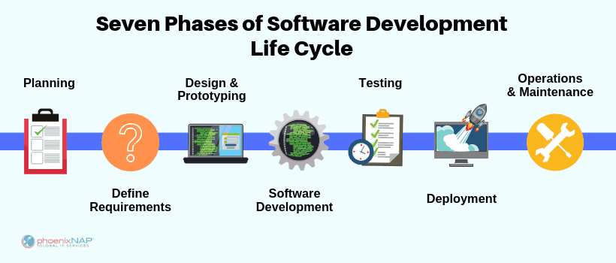

Figure 3.1 SDLC (Source:Internet)

System and Control flow diagram

The diagram below shows how the software works in its core form.

Buyer

NO

Check if books are available or not

Search data

Exit

YES

Store Details

Get details Details

Sign up/sign in

to caryt

Display Details

Add to Cart

Order placed

Check Out

Exit

Figure 3.3 Control Flow for Customers (Source: Student Group 2022)

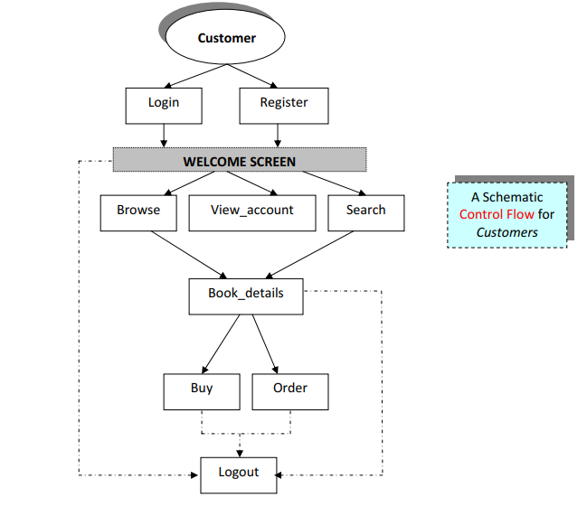

Figure 3.2 System flow diagram (Source: Student Group 2022)

Flowchart

A flowchart is a type of diagram that represents a workflow or process. Use of flowchart makes understanding as well as creating software easy. For our software, we have created a flowing flowchart. Since our program id a menu-based program, we have some pre-defined choices as shown below.

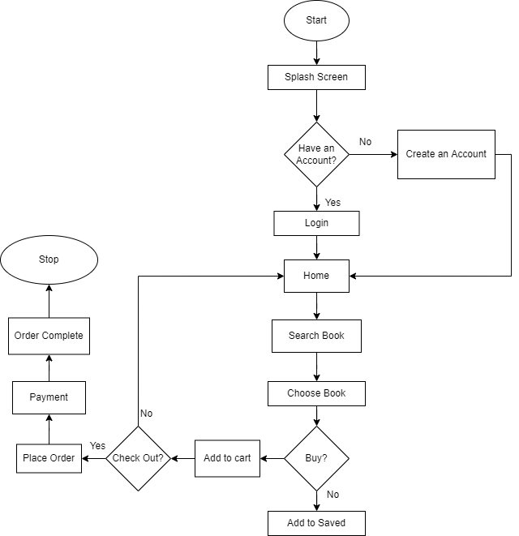

Figure 3.4 Flowchart (Source: Student Group 2022)

## 3.3Database Management:

The database management system (DBMS) is the software that interacts with end users, applications, and the database itself to capture and analyze the data. The DBMS software additionally encompasses the core facilities provided to administer the database. The sum total of the database, the DBMS and the associated applications can be referred to as a "database system". Often the term "database" is also used to loosely refer to any of the DBMS, the database system or an application associated with the database. Since database is an organized collection of data, the data is typically organized to model relevant aspects of reality, in a way that supports processes requiring this information. For this software, we will be using mySQL as our database management tool. Database management systems are specially designed applications that interact with the user, other applications, and the database itself to capture and analyze data. Database management comprises a number of proactive techniques to prevent the deleterious effects of data growth.

Data Collection and management

In order to support all the information followed in this software, this software will include 3 main tables. First table will consist of login information. Its attribute will be id and password. Id will consist of user id and password field will consist of password information. Second table will be our main table to store customer data. The third table will consist of billing information. Its attributes will be amount. All data will be given by customer and will be entered by receptionist. Attributes of two main database tables are given as follow:

**Table 1: Login Information**

|  |  |  |
| --- | --- | --- |
| **Attribute name:** | **Data Type:** | **Attribute Type:** |
| username | user name ID | varchar (10) |
| password | password for that user ID | varchar (10) |

**Table 2: Customer data**

|  |  |  |
| --- | --- | --- |
| **Attribute Name:** | **Data Type:** | **Attribute Type:** |
| name | customer name | varchar (40) |
| number | customer number | int |
| email | customer email | varchar (40) |
| Address line 01 | Flat no | int |
| Address line 01 | street | varchar (10) |
| City : | City name | varchar (15) |
| State : | State name | varchar (10) |
| Country | Country name | varchar (10) |
| Pin code | pin | int |

**Table 3: Attribute of books**

|  |  |  |
| --- | --- | --- |
| **Attribute Name** | **Data Type** | **Attribute Type:** |
| name | Book name | varchar (100) |
| rate | Book rate | int |

ER Diagram

An entity-relationship diagram (ERD) is a data modeling technique that graphically illustrates an information system’s entities and the relationships between those entities. An ERD is a conceptual and representational model of data used to represent the entity framework infrastructure. For this project, the given basic ER diagram shows how data are flowing and how those data were to be handled.

Figure 3.5 ER Diagram (Source: Student Group 2022)

1

1

M

1

1

M

1

1

user

Choose items

Book

Cart

Adds to

order

confirms

contact

Write query

# CHAPTER 4: EPILOGUE

## 4.1 Work Schedule:

As this being our first project and this project is quite simple, so we will focus more time learning about tools rather than making project. We will try to balance between learning how codes work and researching necessary details about our project. As we have only 8-10 weeks to clear our project as well as documentation and report, we are planning to spend our weeks as follows:

Week 1-2:

As both HTML and CSS being new for all of us, we will spend our first and second week for learning about new work place and we will also focus for researching about our project. We will also take notes about our progress making easier to create documentation and report in future week.

Week 3-5:

We will focus our week 3-6 for actual coding and designing. Within the period of 2 weeks, we will finish our complete designing as well as some major programming related to actual software and database management.

Week 6-7:

We will make combine all our work and we will process and complete the project and the final testing will be done in the last days. We will test the program and take feedback from others.

We will sum up the project and discussions among team member. And we will demonstrate the final product to our department.

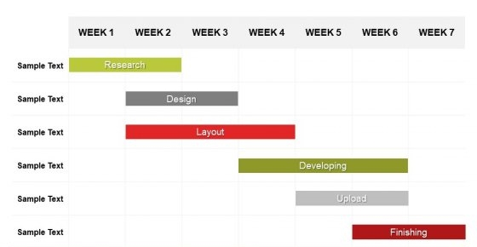

Figure 4.1 Gantt chart (Source: Student Group 2022)

# CHAPTER 5: RESULT AND CONCLUSION

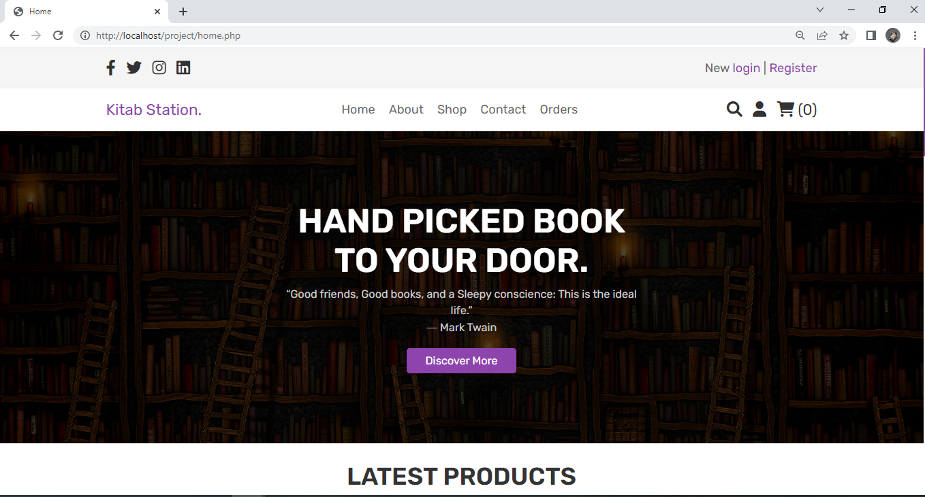

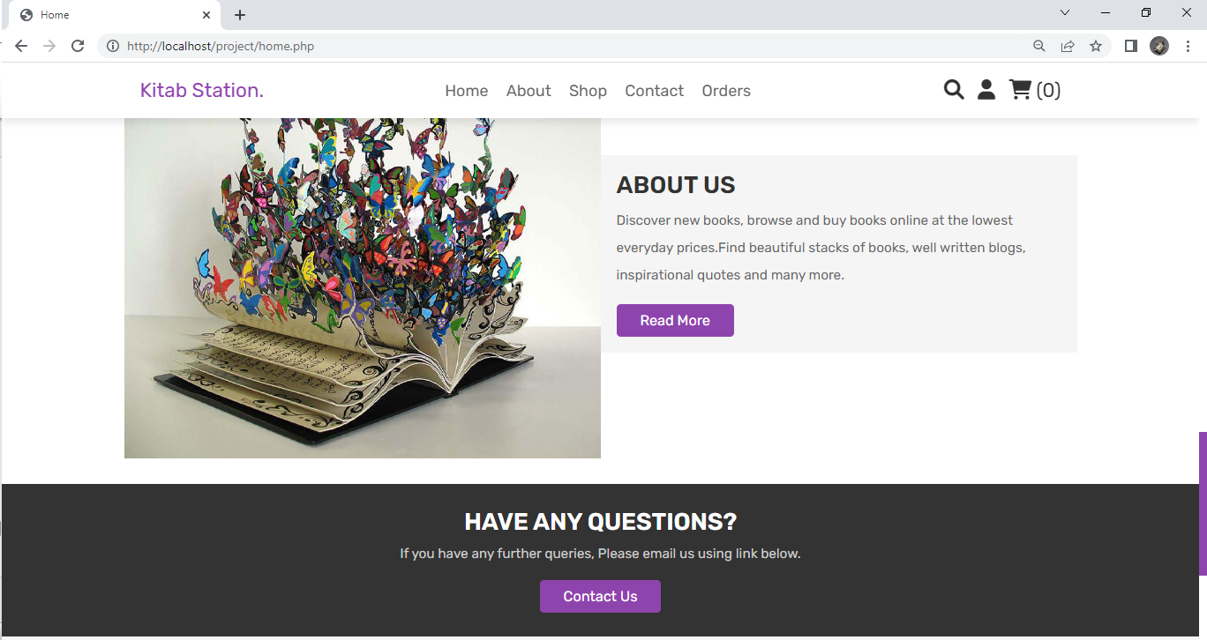

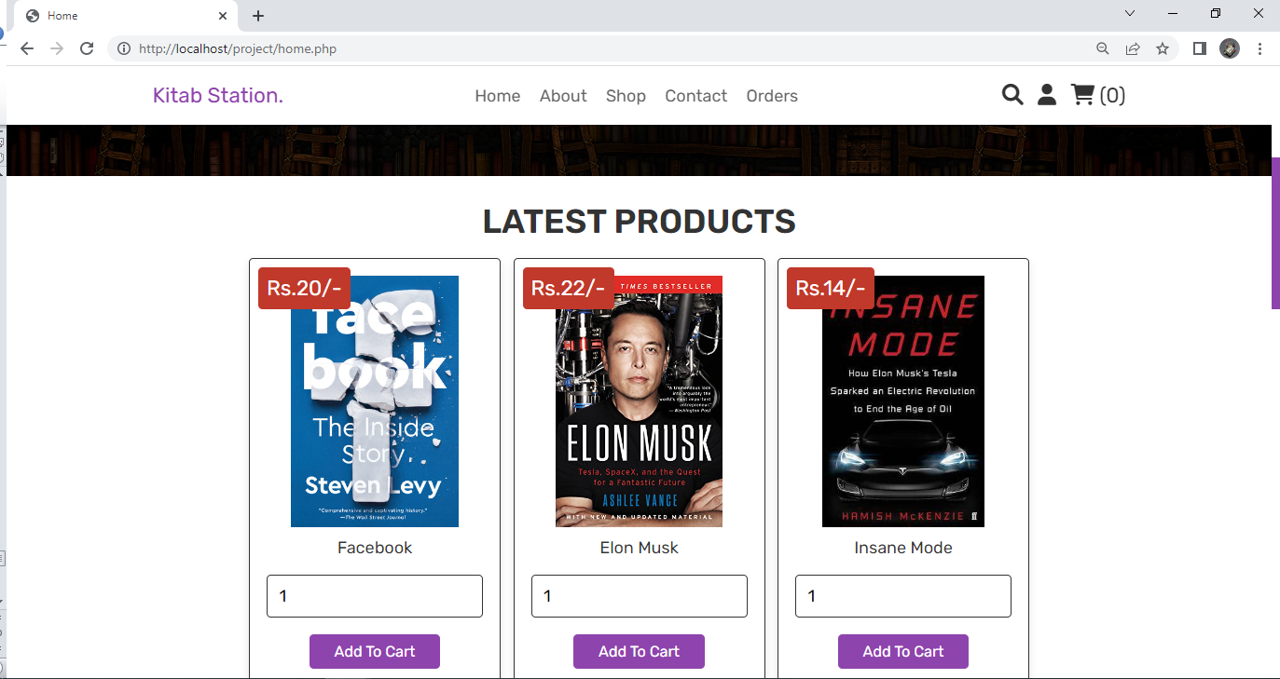

Figure : Home Page (Source: Student Group 2022)

This the Home page of our E-Commerce Book-Store. It contains the Home, About, Shop, Contact, Search Account and Cart options at its header. There is the list of latest products on its middle section of the page. There are quick links, Extra links, Contact info and Social media links on footer. It’s frontend of our project is made by HTML, CSS and JavaScript. If any customer wants to contact the admin there is Contact us option on the home page.

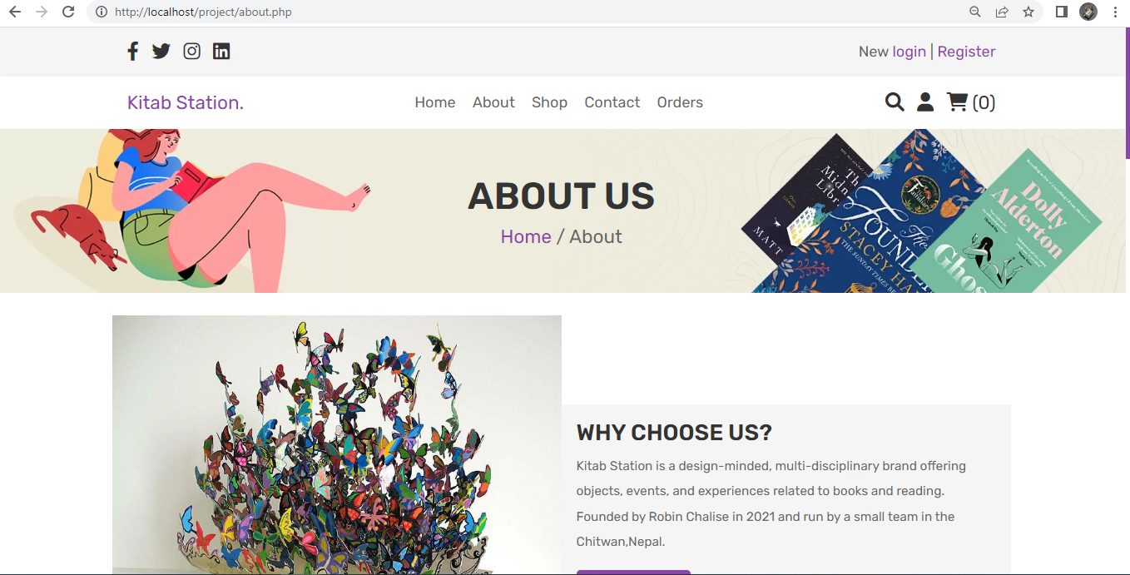

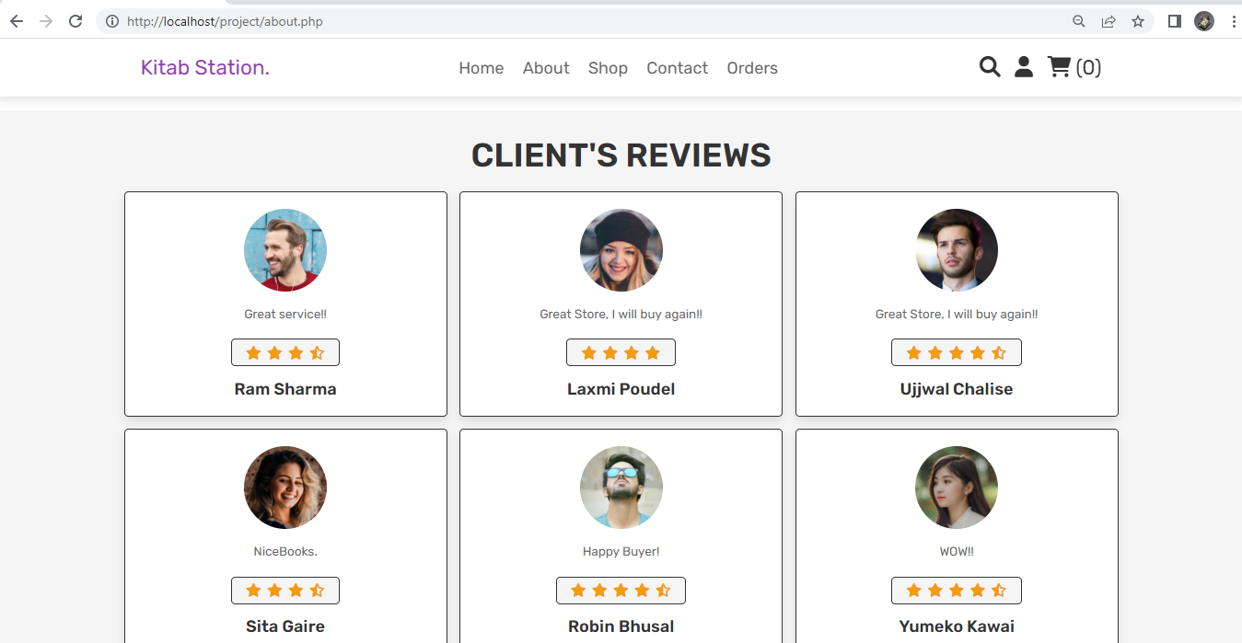

Figure : About Page (Source: Student Group 2022)

This is the About page of our site where we have include the static ‘Why choosing us’, client’s review & Few author name and social media links.

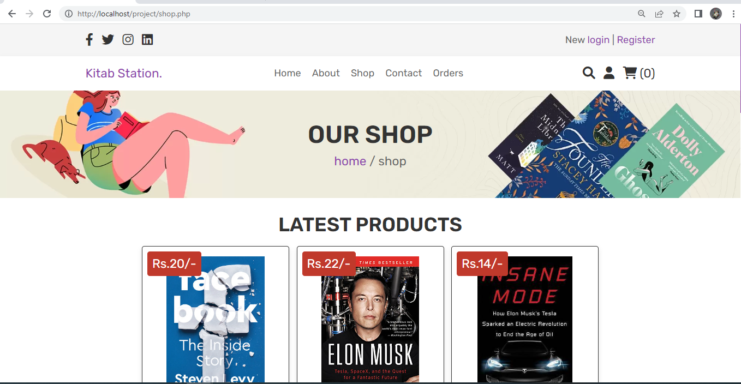

Figure : Shop Page (Source: Student Group 2022)

This is Shop Page of our site where customers can buy and cart the books which is available. Name, photo and price of the book is shown here.

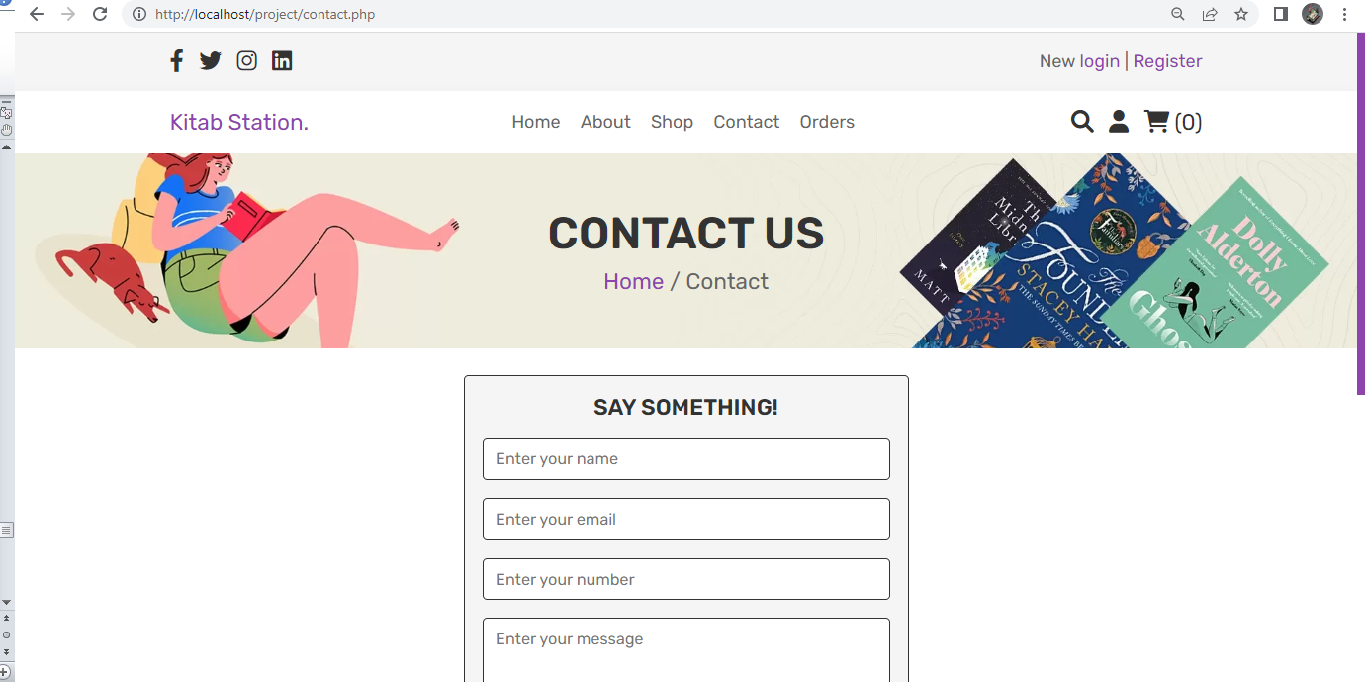

Figure : Contact Page (Source: Student Group 2022)

This section of our project contains the communication and feedback option for the buyers.

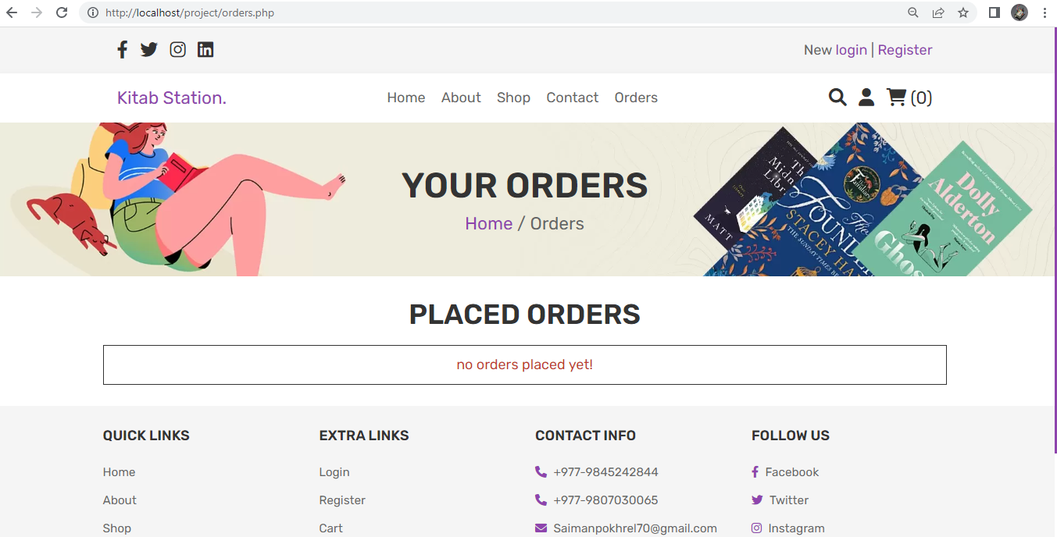

Figure : Order Page (Source: Student Group 2022)

This is the dashboard for the buyers to fix their order and add the quantity and so on.

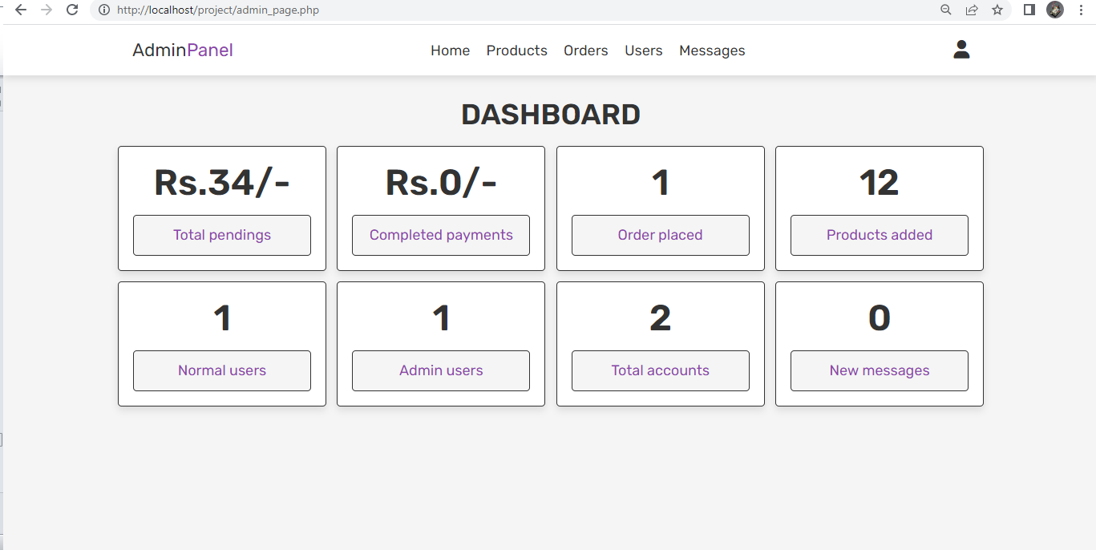

Figure : Admin Page (Source: Student Group 2022)

This is the Admin panel of our project where we can manage and monitor the buyers, their details, product, price, photo and so on.

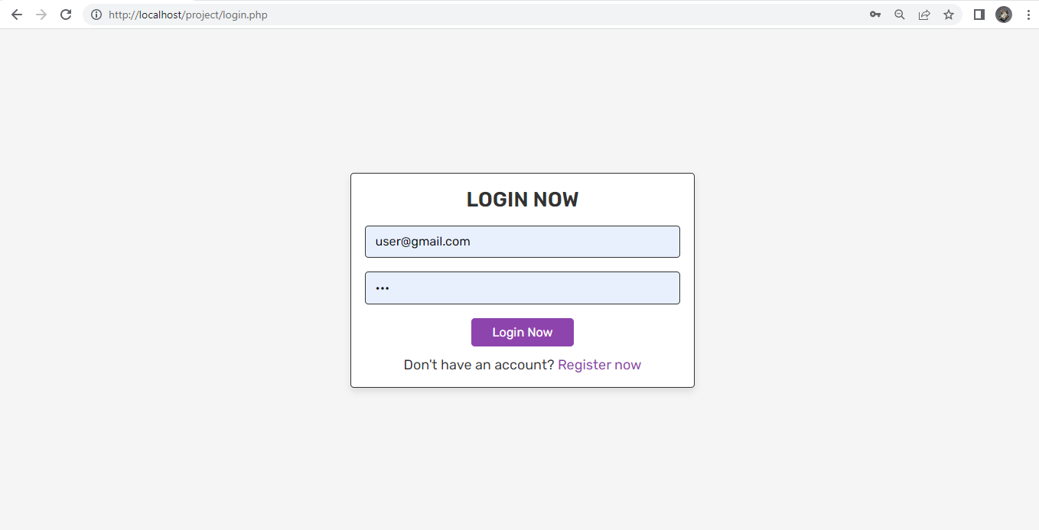

Figure : Login Page (Source: Student Group 2022)

This is the Log in panel where user can login and register. Admin of the site too log in to admin dashboard from this section of site.

# CHAPTER 6: CONCLUSION AND FUTURE ENHANCEMENT

7.1 Conclusion

This project is completely based on online bookstore.E-Commerce is moving towards technology to update themselves and to improve the quality of their services. Online bookstore has many advantages compared to its counterparts such as physical book store, the online bookstore allows it's user to shop at one place where in physical store the books are scattered at the different places which consumes a lot of time and online bookstore helps in saving that time and it also avoids the problem of unavailability of books at physical store as numerous vendors from different places sell their books at one place. This project is efficient in maintaining user’s records and can perform operations on it, also reduces the work load on the shop owner of knowing the quantity of books available and which books are available and keeps the records of how many books are purchased and sold.

7.2 Future Scope

With the world becoming more and more digital everyday there is no surprise that this project has very vast scope in future. Buyers are increasingly looking at convenient ways to buy book. They prefer to use options available on their mobile or laptop to book appointments. The pandemic has made sure that digital modes are embraced even by sections of society that was either hesitant earlier or had limited access to the internet or such tools. Having a presence on the internet is a starting point. The following are the future scope for the project: -

* User Interface should be improved
* Payment Method should be added
* Payment Gateway Should be integrated
* Book category should be included
* Log in Panel Should be made more interactive

# REFERENCES

1. Alexandrou, M., n.d. , Web Development Methodology , mariosalexandrou.com [blog]
2. En.wikipedia.org. 2022. HTML-Wikipedia. [online] Available at: <https://en.wikipedia.org/wiki/HTML> [Accessed 16 October 2022].
3. En.wikipedia.org. 2022. CSS - Wikipedia. [online] Available at: <https://en.wikipedia.org/wiki/CSS> [Accessed 16 October 2022].
4. En.wikipedia.org. 2022. XAMPP - Wikipedia. [online] Available at: <https://en.wikipedia.org/wiki/XAMPP> [Accessed 16 October 2022].
5. En.wikipedia.org. 2022. MySQL - Wikipedia. [online] Available at: <https://en.wikipedia.org/wiki/MySQL> [Accessed 16 October 2022].
6. En.wikipedia.org. 2022. Visual Studio Code - Wikipedia. [online] Available at: <https://en.wikipedia.org/wiki/Visual_Studio_Code> [Accessed 16 October 2022].
7. Coursera. 2022. [online] Available at: <https://www.coursera.org/learn/database-applications-php> [Accessed 16 October 2022].
8. BooksMandala. 2022. BooksMandala - Discover something new. [online] Available at: <https://booksmandala.com/> [Accessed 16 October 2022].
9. Infi.store. 2022. Infi Store [online] Available at: <https://infi.store/> [Accessed 16 October 2022].
10. EEE Recommended Practice for Software Design Descriptions IEEE Std 1016- 1998
11. IEEE Recommended Practice for Software Requirements Specifications - IEEE Std 830-1998
12. IEEE Standard for Software Test Documentation IEEE Std 829-1998

# APPENDIX

# Admin_Style.CSS

@import url('https://fonts.googleapis.com/css2?family=Rubik:wght@300;400;500;600&display=swap');

:root{

--purple:#8e44ad;

--red:#c0392b;

--orange:#f39c12;

--black:#333;

--white:#fff;

--light-color:#666;

--light-white:#ccc;

--light-bg:#f5f5f5;

--border:.1rem solid var(--black);

--box-shadow:0 .5rem 1rem rgba(0,0,0,.1);

}

*{

font-family: 'Rubik', sans-serif;

margin:0; padding:0;

box-sizing: border-box;

outline: none; border:none;

text-decoration: none;

transition:all .2s linear;

}

*::selection{

background-color: var(--purple);

color:var(--white);

}

*::-webkit-scrollbar{

height: .5rem;

width: 1rem;

}

*::-webkit-scrollbar-track{

background-color: transparent;

}

*::-webkit-scrollbar-thumb{

background-color: var(--purple);

}

html{

font-size: 62.5%;

overflow-x: hidden;

}

body{

background-color: var(--light-bg);

}

section{

padding:3rem 2rem;

}

.title{

text-align: center;

margin-bottom: 2rem;

text-transform: uppercase;

color:var(--black);

font-size: 4rem;

}

.empty{

padding:1.5rem;

text-align: center;

border:var(--border);

background-color: var(--white);

color:var(--red);

font-size: 2rem;

}

.message{

position: sticky;

top:0;

margin:0 auto;

max-width: 1200px;

background-color: var(--light-bg);

padding:2rem;

display: flex;

align-items: center;

justify-content: space-between;

z-index: 10000;

gap:1.5rem;

}

.message span{

font-size: 2rem;

color:var(--black);

}

.message i{

cursor: pointer;

color:var(--red);

font-size: 2.5rem;

}

.message i:hover{

transform: rotate(90deg);

}

.btn,

.option-btn,

.delete-btn,

.white-btn{

display: inline-block;

margin-top: 1rem;

padding:1rem 3rem;

cursor: pointer;

color:var(--white);

font-size: 1.8rem;

border-radius: .5rem;

text-transform: capitalize;

}

.btn:hover,

.option-btn:hover,

.delete-btn:hover{

background-color: var(--black);

}

.white-btn,

.btn{

background-color: var(--purple);

}

.option-btn{

background-color: var(--orange);

}

.delete-btn{

background-color: var(--red);

}

.white-btn:hover{

background-color: var(--white);

color:var(--black);

}

@keyframes fadeIn {

0%{

transform: translateY(1rem);

opacity: .2s;

}

}

.header{

position: sticky;

top:0; left:0; right:0;

z-index: 1000;

background-color: var(--white);

box-shadow: var(--box-shadow);

}

.header .flex{

display: flex;

align-items: center;

padding:2rem;

justify-content: space-between;

position: relative;

max-width: 1200px;

margin:0 auto;

}

.header .flex .logo{

font-size: 2.5rem;

color:var(--black);

}

.header .flex .logo span{

color:var(--purple);

}

.header .flex .navbar a{

margin:0 1rem;

font-size: 2rem;

color:var(--black);

}

.header .flex .navbar a:hover{

color:var(--purple);

}

.header .flex .icons div{

margin-left: 1.5rem;

font-size: 2.5rem;

cursor: pointer;

color:var(--black);

}

.header .flex .icons div:hover{

color:var(--purple);

}

.header .flex .account-box{

position: absolute;

top:120%; right:2rem;

width: 30rem;

box-shadow: var(--box-shadow);

border-radius: .5rem;

padding:2rem;

text-align: center;

border-radius: .5rem;

border:var(--border);

background-color: var(--white);

display: none;

animation:fadeIn .2s linear;

}

.header .flex .account-box.active{

display: inline-block;

}

.header .flex .account-box p{

font-size: 2rem;

color:var(--light-color);

margin-bottom: 1.5rem;

}

.header .flex .account-box p span{

color:var(--purple);

}

.header .flex .account-box .delete-btn{

margin-top: 0;

}

.header .flex .account-box div{

margin-top: 1.5rem;

font-size: 2rem;

color:var(--light-color);

}

.header .flex .account-box div a{

color:var(--orange);

}

.header .flex .account-box div a:hover{

text-decoration: underline;

}

#menu-btn{

display: none;

}

.dashboard .box-container{

display: grid;

grid-template-columns: repeat(auto-fit, minmax(25rem, 1fr));

gap:1.5rem;

max-width: 1200px;

margin:0 auto;

align-items: flex-start;

}

.dashboard .box-container .box{

border-radius: .5rem;

padding:2rem;

background-color: var(--white);

box-shadow: var(--box-shadow);

border:var(--border);

text-align: center;

}

.dashboard .box-container .box h3{

font-size: 5rem;

color:var(--black);

}

.dashboard .box-container .box p{

margin-top: 1.5rem;

padding:1.5rem;

background-color: var(--light-bg);

color:var(--purple);

font-size: 2rem;

border-radius: .5rem;

border:var(--border);

}

.add-products form{

background-color: var(--white);

border-radius: .5rem;

padding:2rem;

text-align: center;

box-shadow: var(--box-shadow);

border:var(--border);

max-width: 50rem;

margin:0 auto;

}

.add-products form h3{

font-size: 2.5rem;

text-transform: uppercase;

color:var(--black);

margin-bottom: 1.5rem;

}

.add-products form .box{

width: 100%;

background-color: var(--light-bg);

border-radius: .5rem;

margin:1rem 0;

padding:1.2rem 1.4rem;

color:var(--black);

font-size: 1.8rem;

border:var(--border);

}

.show-products .box-container{

display: grid;

grid-template-columns: repeat(auto-fit, 30rem);

justify-content: center;

gap:1.5rem;

max-width: 1200px;

margin:0 auto;

align-items: flex-start;

}

.show-products{

padding-top: 0;

}

.show-products .box-container .box{

text-align: center;

padding:2rem;

border-radius: .5rem;

border:var(--border);

box-shadow: var(--box-shadow);

background-color: var(--white);

}

.show-products .box-container .box img{

height: 30rem;

}

.show-products .box-container .box .name{

padding:1rem 0;

font-size: 2rem;

color:var(--black);

}

.show-products .box-container .box .price{

padding:1rem 0;

font-size: 2.5rem;

color:var(--red);

}

.edit-product-form{

min-height: 100vh;

background-color: rgba(0,0,0,.7);

display: flex;

align-items: center;

justify-content: center;

padding:2rem;

overflow-y: scroll;

position: fixed;

top:0; left:0;

z-index: 1200;

width: 100%;

}

.edit-product-form form{

width: 50rem;

padding:2rem;

text-align: center;

border-radius: .5rem;

background-color: var(--white);

}

.edit-product-form form img{

height: 25rem;

margin-bottom: 1rem;

}

.edit-product-form form .box{

margin:1rem 0;

padding:1.2rem 1.4rem;

border:var(--border);

border-radius: .5rem;

background-color: var(--light-bg);

font-size: 1.8rem;

color:var(--black);

width: 100%;

}

.orders .box-container{

display: grid;

grid-template-columns: repeat(auto-fit, 30rem);

justify-content: center;

gap:1.5rem;

max-width: 1200px;

margin:0 auto;

align-items: flex-start;

}

.orders .box-container .box{

background-color: var(--white);

padding:2rem;

border:var(--border);

box-shadow: var(--box-shadow);

border-radius: .5rem;

}

.orders .box-container .box p{

padding-bottom: 1rem;

font-size: 2rem;

color:var(--light-color);

}

.orders .box-container .box p span{

color:var(--purple);

}

.orders .box-container .box form{

text-align: center;

}

.orders .box-container .box form select{

border-radius: .5rem;

margin:.5rem 0;

width: 100%;

background-color: var(--light-bg);

border:var(--border);

padding:1.2rem 1.4rem;

font-size: 1.8rem;

color:var(--black);

}

.users .box-container{

display: grid;

grid-template-columns: repeat(auto-fit, 30rem);

justify-content: center;

gap:1.5rem;

max-width: 1200px;

margin:0 auto;

align-items: flex-start;

}

.users .box-container .box{

background-color: var(--white);

padding:2rem;

border:var(--border);

box-shadow: var(--box-shadow);

border-radius: .5rem;

text-align: center;

}

.users .box-container .box p{

padding-bottom: 1.5rem;

font-size: 2rem;

color:var(--light-color);

}

.users .box-container .box p span{

color:var(--purple);

}

.users .box-container .box .delete-btn{

margin-top: 0;

}

.messages .box-container{

display: grid;

grid-template-columns: repeat(auto-fit, 35rem);

justify-content: center;

gap:1.5rem;

max-width: 1200px;

margin:0 auto;

align-items: flex-start;

}

.messages .box-container .box{

background-color: var(--white);

padding:2rem;

border:var(--border);

box-shadow: var(--box-shadow);

border-radius: .5rem;

}

.messages .box-container .box p{

padding-bottom: 1.5rem;

font-size: 2rem;

color:var(--light-color);

line-height: 1.5;

}

.messages .box-container .box p span{

color:var(--purple);

}

.messages .box-container .box .delete-btn{

margin-top: 0;

}

/* media queries */

@media (max-width:991px){

html{

font-size: 55%;

}

}

@media (max-width:768px){

#menu-btn{

display: inline-block;

}

.header .flex .navbar{

position: absolute;

top:99%; left:0; right:0;

background-color: var(--white);

border-top: var(--border);

border-bottom: var(--border);

clip-path: polygon(0 0, 100% 0, 100% 0, 0 0);

}

.header .flex .navbar.active{

clip-path: polygon(0 0, 100% 0, 100% 100%, 0 100%);

}

.header .flex .navbar a{

margin:2rem;

display: block;

}

}

@media (max-width:450px){

html{

font-size: 50%;

}

.title{

font-size: 3rem;

}

}

**Style.CSS**

@import url('https://fonts.googleapis.com/css2?family=Rubik:wght@300;400;500;600&display=swap');

:root{

--purple:#8e44ad;

--red:#c0392b;

--orange:#f39c12;

--black:#333;

--white:#fff;

--light-color:#666;

--light-white:#ccc;

--light-bg:#f5f5f5;

--border:.1rem solid var(--black);

--box-shadow:0 .5rem 1rem rgba(0,0,0,.1);

}

*{

font-family: 'Rubik', sans-serif;

margin:0; padding:0;

box-sizing: border-box;

outline: none; border:none;

text-decoration: none;

transition:all .2s linear;

}

*::selection{

background-color: var(--purple);

color:var(--white);

}

*::-webkit-scrollbar{

height: .5rem;

width: 1rem;

}

*::-webkit-scrollbar-track{

background-color: transparent;

}

*::-webkit-scrollbar-thumb{

background-color: var(--purple);

}

html{

font-size: 62.5%;

overflow-x: hidden;

}

section{

padding:3rem 2rem;

}

.empty{

padding:1.5rem;

text-align: center;

border:var(--border);

background-color: var(--white);

color:var(--red);

font-size: 2rem;

}

.message{

position: sticky;

top:0;

margin:0 auto;

max-width: 1200px;

background-color: var(--white);

padding:2rem;

display: flex;

align-items: center;

justify-content: space-between;

z-index: 10000;

gap:1.5rem;

}

.message span{

font-size: 2rem;

color:var(--black);

}

.message i{

cursor: pointer;

color:var(--red);

font-size: 2.5rem;

}

.message i:hover{

transform: rotate(90deg);

}

.title{

text-align: center;

margin-bottom: 2rem;

text-transform: uppercase;

color:var(--black);

font-size: 4rem;

}

.btn,

.option-btn,

.delete-btn,

.white-btn{

display: inline-block;

margin-top: 1rem;

padding:1rem 3rem;

cursor: pointer;

color:var(--white);

font-size: 1.8rem;

border-radius: .5rem;

text-transform: capitalize;

}

.btn:hover,

.option-btn:hover,

.delete-btn:hover{

background-color: var(--black);

}

.white-btn,

.btn{

background-color: var(--purple);

}

.option-btn{

background-color: var(--orange);

}

.delete-btn{

background-color: var(--red);

}

.white-btn:hover{

background-color: var(--white);

color:var(--black);

}

.heading{

min-height: 30vh;

display: flex;

flex-flow: column;

align-items: center;

justify-content: center;

gap:1rem;

background: url(../images/heading-bg.webp) no-repeat;

background-size: cover;

background-position: center;

text-align: center;

}

.heading h3{

font-size: 5rem;

color:var(--black);

text-transform: uppercase;

}

.heading p{

font-size: 2.5rem;

color:var(--light-color);

}

.heading p a{

color:var(--purple);

}

.heading p a:hover{

text-decoration: underline;

}

@keyframes fadeIn {

0%{

transform: translateY(1rem);

opacity: .2s;

}

}

.form-container{

min-height: 100vh;

background-color: var(--light-bg);

display: flex;

align-items: center;

justify-content: center;

padding:2rem;

}

.form-container form{

padding:2rem;

width: 50rem;

border-radius: .5rem;

box-shadow: var(--box-shadow);

border:var(--border);

background-color: var(--white);

text-align: center;

}

.form-container form h3{

font-size: 3rem;

margin-bottom: 1rem;

text-transform: uppercase;

color:var(--black);

}

.form-container form .box{

width: 100%;

border-radius: .5rem;

background-color: var(--light-bg);

padding:1.2rem 1.4rem;

font-size: 1.8rem;

color:var(--black);

border:var(--border);

margin:1rem 0;

}

.form-container form p{

padding-top: 1.5rem;

font-size: 2rem;

color:var(--black);

}

.form-container form p a{

color:var(--purple);

}

.form-container form p a:hover{

text-decoration: underline;

}

.header .header-1{

background-color: var(--light-bg);

}

.header .header-1 .flex{

padding:2rem;

display: flex;

align-items: center;

justify-content: space-between;

max-width: 1200px;

margin:0 auto;

}

.header .header-2{

background-color: var(--white);

box-shadow: var(--box-shadow);

}

.header .header-2.active{

position: fixed;

top:0; left:0; right:0;

z-index: 1000;

}

.header .header-2 .flex{

padding:2rem;

display: flex;

align-items: center;

justify-content: space-between;

max-width: 1200px;

margin:0 auto;

position: relative;

}

.header .header-1 .flex .share a{

font-size: 2.5rem;

margin-right: 1.5rem;

color:var(--black);

}

.header .header-1 .flex .share a:hover{

color:var(--purple);

}

.header .header-1 .flex p{

font-size: 2rem;

color:var(--light-color);

}

.header .header-1 .flex p a{

color:var(--purple);

}

.header .header-1 .flex p a:hover{

text-decoration: underline;

}

.header .header-2 .flex .logo{

font-size: 2.5rem;

color:var(--purple);

}

.header .header-2 .flex .navbar a{

margin:0 1rem;

font-size: 2rem;

color:var(--light-color);

}

.header .header-2 .flex .navbar a:hover{

color:var(--purple);

text-decoration: underline;

}

.header .header-2 .flex .icons > *{

font-size: 2.5rem;

color:var(--black);

cursor: pointer;

margin-left: 1.5rem;

}

.header .header-2 .flex .icons > *:hover{

color:var(--purple);

}

#menu-btn{

display: none;

}

.header .header-2 .flex .user-box{

position: absolute;

top:120%; right:2rem;

background-color: var(--white);

border-radius: .5rem;

box-shadow: var(--box-shadow);

border:var(--border);

padding:2rem;

text-align: center;

width: 30rem;

display: none;

animation: fadeIn .2s linear;

}

.header .header-2 .flex .user-box.active{

display: inline-block;

}

.header .header-2 .flex .user-box p{

font-size: 2rem;

color:var(--light-color);

margin-bottom: 1.5rem;

}

.header .header-2 .flex .user-box p span{

color:var(--purple);

}

.header .header-2 .flex .user-box .delete-btn{

margin-top: 0;

}

.home{

min-height: 70vh;

background:linear-gradient(rgba(0,0,0,.7), rgba(0,0,0,.7)), url(../images/hbg.jpg);

background-size: cover;

background-position: center;

display: flex;

align-items: center;

justify-content: center;

}

.home .content{

text-align: center;

width: 60rem;

}

.home .content h3{

font-size: 5.5rem;

color:var(--white);

text-transform: uppercase;

}

.home .content p{

font-size:1.8rem;

color:var(--light-white);

padding:1rem 0;

line-height: 1.5;

}

.products .box-container{

max-width: 1200px;

margin:0 auto;

display: grid;

grid-template-columns: repeat(auto-fit, 30rem);

align-items: flex-start;

gap:1.5rem;

justify-content: center;

}

.products .box-container .box{

border-radius: .5rem;

background-color: var(--white);

box-shadow: var(--box-shadow);

padding:2rem;

text-align: center;

border:var(--border);

position: relative;

}

.products .box-container .box .image{

height: 30rem;

}

.products .box-container .box .name{

padding:1rem 0;

font-size: 2rem;

color:var(--black);

}

.products .box-container .box .qty{

width: 100%;

padding:1.2rem 1.4rem;

border-radius: .5rem;

border:var(--border);

margin:1rem 0;

font-size: 2rem;

}

.products .box-container .box .price{

position: absolute;

top:1rem; left:1rem;

border-radius: .5rem;

padding:1rem;

font-size: 2.5rem;

color:var(--white);

background-color: var(--red);

}

.about .flex{

max-width: 1200px;

margin:0 auto;

display: flex;

align-items: center;

flex-wrap: wrap;

}

.about .flex .image{

flex:1 1 40rem;

}

.about .flex .image img{

width: 100%;

}

.about .flex .content{

flex:1 1 40rem;

padding:2rem;

background-color: var(--light-bg);

}

.about .flex .content h3{

font-size: 3rem;

color:var(--black);

text-transform: uppercase;

}

.about .flex .content p{

padding:1rem 0;

line-height: 2;

font-size: 1.7rem;

color:var(--light-color);

}

.home-contact{

background-color: var(--black);

}

.home-contact .content{

max-width: 60rem;

text-align: center;

margin:0 auto;

}

.home-contact .content h3{

font-size: 3rem;

text-transform: uppercase;

color:var(--white);

}

.home-contact .content p{

padding:1rem 0;

line-height: 1.5;

color:var(--light-white);

font-size: 1.7rem;

}

.reviews{

background-color: var(--light-bg);

}

.reviews .box-container{

max-width: 1200px;

margin:0 auto;

display: grid;

grid-template-columns: repeat(auto-fit, minmax(30rem, 1fr));

align-items: center;

gap:1.5rem;

justify-content: center;

}

.reviews .box-container .box{

background-color: var(--white);

box-shadow: var(--box-shadow);

border:var(--border);

border-radius: .5rem;

text-align: center;

padding:2rem;

}

.reviews .box-container .box img{

height: 10rem;

width: 10rem;

border-radius: 50%;

}

.reviews .box-container .box p{

padding:1rem 0;

line-height: 2;

color:var(--light-color);

font-size: 1.5rem;

}

.reviews .box-container .box .stars{

background-color: var(--light-bg);

display: inline-block;

margin:.5rem 0;

border-radius: .5rem;

border:var(--border);

padding:.5rem 1.5rem;

}

.reviews .box-container .box .stars i{

font-size: 1.7rem;

color:var(--orange);

margin:.2rem;

}

.reviews .box-container .box h3{

font-size: 2rem;

color:var(--black);

margin-top: 1rem;

}

.authors .box-container{

max-width: 1200px;

margin:0 auto;

display: grid;

grid-template-columns: repeat(auto-fit, minmax(30rem, 1fr));

align-items: center;

gap:1.5rem;

justify-content: center;

}

.authors .box-container .box{

position: relative;

text-align: center;

border:var(--border);

box-shadow: var(--box-shadow);

overflow: hidden;

border-radius: .5rem;

}

.authors .box-container .box img{

width: 100%;

height: 40rem;

object-fit: cover;

}

.authors .box-container .box .share{

position: absolute;

top:0; left:-10rem;

}

.authors .box-container .box:hover .share{

left: 1rem;

}

.authors .box-container .box .share a{

height: 4.5rem;

width: 4.5rem;

line-height: 4.5rem;

font-size: 2rem;

background-color: var(--white);

border:var(--border);

display: block;

margin-top: 1rem;

color:var(--black);

}

.authors .box-container .box .share a:hover{

background-color: var(--black);

color:var(--white);

}

.authors .box-container .box h3{

font-size: 2.5rem;

color:var(--black);

padding:1.5rem;

background-color: var(--white);

}

.contact form{

margin:0 auto;

background-color: var(--light-bg);

border-radius: .5rem;

border:var(--border);

padding:2rem;

max-width: 50rem;

margin:0 auto;

text-align: center;

}

.contact form h3{

font-size: 2.5rem;

text-transform: uppercase;

margin-bottom: 1rem;

color:var(--black);

}

.contact form .box{

margin:1rem 0;

width: 100%;

border:var(--border);

background-color: var(--white);

padding:1.2rem 1.4rem;

font-size: 1.8rem;

color:var(--black);

border-radius: .5rem;

}

.contact form textarea{

height: 20rem;

resize: none;

}

.shopping-cart .box-container{

max-width: 1200px;

margin:0 auto;

display: grid;

grid-template-columns: repeat(auto-fit, 30rem);

align-items: center;

gap:1.5rem;

justify-content: center;

}

.shopping-cart .box-container .box{

text-align: center;

padding:2rem;

border-radius: .5rem;

background-color: var(--white);

box-shadow: var(--box-shadow);

position: relative;

border:var(--border);

}

.shopping-cart .box-container .box .fa-times{

position: absolute;

top:1rem; right:1rem;

height: 4.5rem;

width: 4.5rem;

line-height: 4.5rem;

font-size: 2rem;

background-color: var(--red);

color:var(--white);

border-radius: .5rem;

}

.shopping-cart .box-container .box .fa-times:hover{

background-color: var(--black);

}

.shopping-cart .box-container .box img{

height: 30rem;

}

.shopping-cart .box-container .box .name{

padding:1rem 0;

font-size: 2rem;

color:var(--black);

}

.shopping-cart .box-container .box .price{

padding:1rem 0;

font-size: 2.5rem;

color:var(--red);

}

.shopping-cart .box-container .box input[type="number"]{

margin:.5rem 0;

border:var(--border);

border-radius: .5rem;

padding:1.2rem 1.4rem;

font-size: 2rem;

color:var(--black);

width: 9rem;

}

.shopping-cart .box-container .box .sub-total{

padding-top: 1.5rem;

font-size: 2rem;

color:var(--light-color);

}

.shopping-cart .box-container .box .sub-total span{

color:var(--red);

}

.shopping-cart .cart-total{

max-width: 1200px;

margin:0 auto;

border:var(--border);

padding:2rem;

text-align: center;

margin-top: 2rem;

border-radius: .5rem;

}

.shopping-cart .cart-total p{

font-size: 2.5rem;

color:var(--light-color);

}

.shopping-cart .cart-total p span{

color:var(--red);

}

.shopping-cart .cart-total .flex{

display: flex;

flex-wrap: wrap;

column-gap:1rem;

margin-top: 1.5rem;

justify-content: center;

}

.shopping-cart .disabled{

pointer-events: none;

opacity: .5;

user-select: none;

}

.display-order{

max-width: 1200px;

margin: 0 auto;

text-align: center;

padding-bottom: 0;

}

.display-order p{

background-color: var(--light-bg);

color:var(--black);

font-size: 2rem;

padding:1rem 1.5rem;

border:var(--border);

display: inline-block;

margin:.5rem;

}

.display-order p span{

color:var(--red);

}

.display-order .grand-total{

margin-top: 2rem;

font-size: 2.5rem;

color:var(--light-color);

}

.display-order .grand-total span{

color:var(--red);

}

.checkout form{

max-width: 1200px;

padding:2rem;

margin:0 auto;

border:var(--border);

background-color: var(--light-bg);

border-radius: .5rem;

}

.checkout form h3{

text-align: center;

margin-bottom: 2rem;

color:var(--black);

text-transform: uppercase;

font-size: 3rem;

}

.checkout form .flex{

display: flex;

flex-wrap: wrap;

gap:1.5rem;

}

.checkout form .flex .inputBox{

flex:1 1 40rem;

}

.checkout form .flex span{

font-size: 2rem;

color:var(--black);

}

.checkout form .flex select,

.checkout form .flex input{

border:var(--border);

width: 100%;

border-radius: .5rem;

width: 100%;

background-color: var(--white);

padding:1.2rem 1.4rem;

font-size: 1.8rem;

margin:1rem 0;

}

.placed-orders .box-container{

max-width: 1200px;

margin:0 auto;

display:flex;

flex-wrap: wrap;

align-items: center;

gap:1.5rem;

}

.placed-orders .box-container .empty{

flex:1;

}

.placed-orders .box-container .box{

flex:1 1 40rem;

border-radius: .5rem;

padding:2rem;

border:var(--border);

background-color: var(--light-bg);

padding:1rem 2rem;

}

.placed-orders .box-container .box p{

padding:1rem 0;

font-size: 2rem;

color:var(--light-color);

}

.placed-orders .box-container .box p span{

color:var(--purple);

}

.search-form form{

max-width: 1200px;

margin:0 auto;

display: flex;

gap:1rem;

}

.search-form form .btn{

margin-top: 0;

}

.search-form form .box{

width: 100%;

padding:1.2rem 1.4rem;

border:var(--border);

font-size: 2rem;

color:var(--black);

background-color: var(--light-bg);

border-radius: .5rem;

}

.footer{

background-color: var(--light-bg);

}

.footer .box-container{

max-width: 1200px;

margin:0 auto;

display: grid;

grid-template-columns: repeat(auto-fit, minmax(25rem, 1fr));

gap:3rem;

}

.footer .box-container .box h3{

text-transform: uppercase;

color:var(--black);

font-size: 2rem;

padding-bottom: 2rem;

}

.footer .box-container .box p,

.footer .box-container .box a{

display: block;

font-size: 1.7rem;

color:var(--light-color);

padding:1rem 0;

}

.footer .box-container .box p i,

.footer .box-container .box a i{

color:var(--purple);

padding-right: .5rem;

}

.footer .box-container .box a:hover{

color:var(--purple);

text-decoration: underline;

}

.footer .credit{

text-align: center;

font-size: 2rem;

color:var(--light-color);

border-top: var(--border);

margin-top: 2.5rem;

padding-top: 2.5rem;

}

.footer .credit span{

color:var(--purple);

}

/* media queries */

@media (max-width:991px){

html{

font-size: 55%;

}

}

@media (max-width:768px){

#menu-btn{

display: inline-block;

}

.header .header-2 .flex .navbar{

position: absolute;

top:99%; left:0; right:0;

background-color: var(--white);

border-top: var(--border);

border-bottom: var(--border);

clip-path: polygon(0 0, 100% 0, 100% 0, 0 0);

}

.header .header-2 .flex .navbar.active{

clip-path: polygon(0 0, 100% 0, 100% 100%, 0 100%);

}

.header .header-2 .flex .navbar a{

display: block;

font-size: 2.5rem;

margin:2rem;

}

.home .content h3{

font-size: 3.5rem;

}

}

@media (max-width:450px){

html{

font-size: 50%;

}

.heading h3{

font-size: 3.5rem;

}

.title{

font-size: 3rem;

}

}

**Admin_script.js**

let navbar = document.querySelector('.header .navbar');

let accountBox = document.querySelector('.header .account-box');

document.querySelector('#menu-btn').onclick = () =>{

navbar.classList.toggle('active');

accountBox.classList.remove('active');

}

document.querySelector('#user-btn').onclick = () =>{

accountBox.classList.toggle('active');

navbar.classList.remove('active');

}

window.onscroll = () =>{

navbar.classList.remove('active');

accountBox.classList.remove('active');

}

document.querySelector('#close-update').onclick = () =>{

document.querySelector('.edit-product-form').style.display = 'none';

window.location.href = 'admin_products.php';

}

**Script.js**

let userBox = document.querySelector('.header .header-2 .user-box');

document.querySelector('#user-btn').onclick = () =>{

userBox.classList.toggle('active');

navbar.classList.remove('active');

}

let navbar = document.querySelector('.header .header-2 .navbar');

document.querySelector('#menu-btn').onclick = () =>{

navbar.classList.toggle('active');

userBox.classList.remove('active');

}

window.onscroll = () =>{

userBox.classList.remove('active');

navbar.classList.remove('active');

if(window.scrollY > 60){

document.querySelector('.header .header-2').classList.add('active');

}else{

document.querySelector('.header .header-2').classList.remove('active');

}

}

PHP Code

<?php

include 'config.php';

session_start();

$user_id = $_SESSION['user_id'];

if(!isset($user_id)){

header('location:login.php');

}

?>

<!DOCTYPE html>

<html lang="en">

<head>

<meta charset="UTF-8">

<meta http-equiv="X-UA-Compatible" content="IE=edge">

<meta name="viewport" content="width=device-width, initial-scale=1.0">

<title>About</title>

<!-- font awesome cdn link -->

<link rel="stylesheet" href="https://cdnjs.cloudflare.com/ajax/libs/font-awesome/6.0.0/css/all.min.css">

<!-- custom css file link -->

<link rel="stylesheet" href="css/style.css">

</head>

<body>

<?php include 'header.php'; ?>

<div class="heading">

<h3>About us</h3>

<p> <a href="home.php">Home</a> / About </p>

</div>

<section class="about">

<div class="flex">

<div class="image">

<img src="images/abt.jpg" alt="">

</div>

<div class="content">

<h3>why choose us?</h3>

<p>Lorem ipsum dolor sit amet, consectetur adipisicing elit. Eveniet voluptatibus aut hic molestias, reiciendis natus fuga, cumque excepturi veniam ratione iure. Excepturi fugiat placeat iusto facere id officia assumenda temporibus?</p>

<p>Lorem ipsum dolor, sit amet consectetur adipisicing elit. Impedit quos enim minima ipsa dicta officia corporis ratione saepe sed adipisci?</p>

<a href="contact.php" class="btn">contact us</a>

</div>

</div>

</section>

<section class="reviews">

<h1 class="title">Client's reviews</h1>

<div class="box-container">

<div class="box">

<img src="images/pic-1.png" alt="">

<p>Great service!!</p>

<div class="stars">

<i class="fas fa-star"></i>

<i class="fas fa-star"></i>

<i class="fas fa-star"></i>

<i class="fas fa-star-half-alt"></i>

</div>

<h3>Ram Sharma</h3>

</div>

<div class="box">

<img src="images/pic-2.png" alt="">

<p>Lorem ipsum dolor sit amet consectetur adipisicing elit. Sunt ad, quo labore fugiat nam accusamus quia. Ducimus repudiandae dolore placeat.</p>

<div class="stars">

<i class="fas fa-star"></i>

<i class="fas fa-star"></i>

<i class="fas fa-star"></i>

<i class="fas fa-star"></i>

</div>

<h3>Laxmi Poudel</h3>

</div>

<div class="box">

<img src="images/pic-3.png" alt="">

<p>Lorem ipsum dolor sit amet consectetur adipisicing elit. Sunt ad, quo labore fugiat nam accusamus quia. Ducimus repudiandae dolore placeat.</p>

<div class="stars">

<i class="fas fa-star"></i>

<i class="fas fa-star"></i>

<i class="fas fa-star"></i>

<i class="fas fa-star"></i>

<i class="fas fa-star-half-alt"></i>

</div>

<h3>Ujjwal Chalise</h3>

</div>

<div class="box">

<img src="images/pic-4.png" alt="">

<p>Lorem ipsum dolor sit amet consectetur adipisicing elit. Sunt ad, quo labore fugiat nam accusamus quia. Ducimus repudiandae dolore placeat.</p>

<div class="stars">

<i class="fas fa-star"></i>

<i class="fas fa-star"></i>

<i class="fas fa-star"></i>

<i class="fas fa-star-half-alt"></i>

</div>

<h3>Sita Gaire</h3>

</div>

<div class="box">

<img src="images/pic-5.png" alt="">

<p>Lorem ipsum dolor sit amet consectetur adipisicing elit. Sunt ad, quo labore fugiat nam accusamus quia. Ducimus repudiandae dolore placeat.</p>

<div class="stars">

<i class="fas fa-star"></i>

<i class="fas fa-star"></i>

<i class="fas fa-star"></i>

<i class="fas fa-star"></i>

<i class="fas fa-star-half-alt"></i>

</div>

<h3>Robin Bhusal</h3>

</div>

<div class="box">

<img src="images/pic-6.png" alt="">

<p>Lorem ipsum dolor sit amet consectetur adipisicing elit. Sunt ad, quo labore fugiat nam accusamus quia. Ducimus repudiandae dolore placeat.</p>

<div class="stars">

<i class="fas fa-star"></i>

<i class="fas fa-star"></i>

<i class="fas fa-star"></i>

<i class="fas fa-star"></i>

<i class="fas fa-star-half-alt"></i>

</div>

<h3>Yumeko Kawai</h3>

</div>

</div>

</section>

<section class="authors">

<h1 class="title">Great Authors</h1>

<div class="box-container">

<div class="box">

<img src="images/A1.jpeg" alt="">

<div class="share">

<a href="#" class="fab fa-facebook-f"></a>

<a href="#" class="fab fa-twitter"></a>

<a href="#" class="fab fa-instagram"></a>

<a href="#" class="fab fa-linkedin"></a>

</div>

<h3>Elon Musk</h3>

</div>

<div class="box">

<img src="images/A2.jpg" alt="">

<div class="share">

<a href="#" class="fab fa-facebook-f"></a>

<a href="#" class="fab fa-twitter"></a>

<a href="#" class="fab fa-instagram"></a>

<a href="#" class="fab fa-linkedin"></a>

</div>

<h3>Steven Levy</h3>

</div>

<div class="box">

<img src="images/A3.jpg" alt="">

<div class="share">

<a href="#" class="fab fa-facebook-f"></a>

<a href="#" class="fab fa-twitter"></a>

<a href="#" class="fab fa-instagram"></a>

<a href="#" class="fab fa-linkedin"></a>

</div>

<h3>John le Carré</h3>

</div>

<div class="box">

<img src="images/A4.jpg" alt="">

<div class="share">

<a href="#" class="fab fa-facebook-f"></a>

<a href="#" class="fab fa-twitter"></a>

<a href="#" class="fab fa-instagram"></a>

<a href="#" class="fab fa-linkedin"></a>

</div>

<h3>Bhairav Aryal</h3>

</div>

<div class="box">

<img src="images/A5.jpg" alt="">

<div class="share">

<a href="#" class="fab fa-facebook-f"></a>

<a href="#" class="fab fa-twitter"></a>

<a href="#" class="fab fa-instagram"></a>

<a href="#" class="fab fa-linkedin"></a>

</div>

<h3>Balakrishna Sama</h3>

</div>

<div class="box">

<img src="images/A6.jpg" alt="">

<div class="share">

<a href="#" class="fab fa-facebook-f"></a>

<a href="#" class="fab fa-twitter"></a>

<a href="#" class="fab fa-instagram"></a>

<a href="#" class="fab fa-linkedin"></a>

</div>

<h3> Bishnu Kumari Waiba(Parijat)</h3>

</div>

</div>

</section>

<?php include 'footer.php'; ?>

<!-- custom js file link -->

<script src="js/script.js"></script>

</body>

</html>

<?php

include 'config.php'

?>

<?php

include 'config.php';

session_start();

$admin_id = $_SESSION['admin_id'];

if(!isset($admin_id)){

header('location:login.php');

};

if(isset($_GET['delete'])){

$delete_id = $_GET['delete'];

mysqli_query($conn, "DELETE FROM `message` WHERE id = '$delete_id'") or die('query failed');

header('location:admin_contacts.php');

}

?>

<!DOCTYPE html>

<html lang="en">

<head>

<meta charset="UTF-8">

<meta http-equiv="X-UA-Compatible" content="IE=edge">

<meta name="viewport" content="width=device-width, initial-scale=1.0">

<title>Messages</title>

<!-- font awesome cdn link -->

<link rel="stylesheet" href="https://cdnjs.cloudflare.com/ajax/libs/font-awesome/6.0.0/css/all.min.css">

<!-- custom admin css file link -->

<link rel="stylesheet" href="css/admin_style.css">

</head>

<body>

<?php include 'admin_header.php'; ?>

<section class="messages">

<h1 class="title"> Messages </h1>

<div class="box-container">

<?php

$select_message = mysqli_query($conn, "SELECT * FROM `message`") or die('query failed');

if(mysqli_num_rows($select_message) > 0){

while($fetch_message = mysqli_fetch_assoc($select_message)){

?>

<div class="box">

<p> User id : <span><?php echo $fetch_message['user_id']; ?></span> </p>

<p> Name : <span><?php echo $fetch_message['name']; ?></span> </p>

<p> Number : <span><?php echo $fetch_message['number']; ?></span> </p>

<p> Email : <span><?php echo $fetch_message['email']; ?></span> </p>

<p> Message : <span><?php echo $fetch_message['message']; ?></span> </p>

<a href="admin_contacts.php?delete=<?php echo $fetch_message['id']; ?>" onclick="return confirm('delete this message?');" class="delete-btn">delete message</a>

</div>

<?php

};

}else{

echo '<p class="empty">you have no messages!</p>';

}

?>

</div>

</section>

<!-- custom admin js file link -->

<script src="js/admin_script.js"></script>

</body>

</html>

<?php

if(isset($message)){

foreach($message as $message){

echo '

<div class="message">

<span>'.$message.'</span>

<i class="fas fa-times" onclick="this.parentElement.remove();"></i>

</div>

';

}

}

?>

<header class="header">

<div class="flex">

<a href="admin_page.php" class="logo">Admin<span>Panel</span></a>

<nav class="navbar">

<a href="admin_page.php">Home</a>

<a href="admin_products.php">Products</a>

<a href="admin_orders.php">Orders</a>

<a href="admin_users.php">Users</a>

<a href="admin_contacts.php">Messages</a>

</nav>

<div class="icons">

<div id="menu-btn" class="fas fa-bars"></div>

<div id="user-btn" class="fas fa-user"></div>

</div>

<div class="account-box">

<p>Username : <span><?php echo $_SESSION['admin_name']; ?></span></p>

<p>Email : <span><?php echo $_SESSION['admin_email']; ?></span></p>

<a href="logout.php" class="delete-btn">logout</a>

<div>New <a href="login.php">login</a> | <a href="register.php">Register</a></div>

</div>

</div>

</header>

<?php

include 'config.php';

session_start();

$admin_id = $_SESSION['admin_id'];

if(!isset($admin_id)){

header('location:login.php');

}

if(isset($_POST['update_order'])){

$order_update_id = $_POST['order_id'];

$update_payment = $_POST['update_payment'];

mysqli_query($conn, "UPDATE `orders` SET payment_status = '$update_payment' WHERE id = '$order_update_id'") or die('query failed');

$message[] = 'payment status has been updated!';

}

if(isset($_GET['delete'])){

$delete_id = $_GET['delete'];

mysqli_query($conn, "DELETE FROM `orders` WHERE id = '$delete_id'") or die('query failed');

header('location:admin_orders.php');

}

?>

<!DOCTYPE html>

<html lang="en">

<head>

<meta charset="UTF-8">

<meta http-equiv="X-UA-Compatible" content="IE=edge">

<meta name="viewport" content="width=device-width, initial-scale=1.0">

<title>Orders</title>

<!-- font awesome cdn link -->

<link rel="stylesheet" href="https://cdnjs.cloudflare.com/ajax/libs/font-awesome/6.0.0/css/all.min.css">

<!-- custom admin css file link -->

<link rel="stylesheet" href="css/admin_style.css">

</head>

<body>

<?php include 'admin_header.php'; ?>

<section class="orders">

<h1 class="title">placed orders</h1>

<div class="box-container">

<?php

$select_orders = mysqli_query($conn, "SELECT * FROM `orders`") or die('query failed');

if(mysqli_num_rows($select_orders) > 0){

while($fetch_orders = mysqli_fetch_assoc($select_orders)){

?>

<div class="box">

<p> User id : <span><?php echo $fetch_orders['user_id']; ?></span> </p>

<p> Placed on : <span><?php echo $fetch_orders['placed_on']; ?></span> </p>

<p> Name : <span><?php echo $fetch_orders['name']; ?></span> </p>

<p> Number : <span><?php echo $fetch_orders['number']; ?></span> </p>

<p> Email : <span><?php echo $fetch_orders['email']; ?></span> </p>

<p> Address : <span><?php echo $fetch_orders['address']; ?></span> </p>

<p> Total products : <span><?php echo $fetch_orders['total_products']; ?></span> </p>

<p> Total price : <span>$<?php echo $fetch_orders['total_price']; ?>/-</span> </p>

<p> Payment method : <span><?php echo $fetch_orders['method']; ?></span> </p>

<form action="" method="post">

<input type="hidden" name="order_id" value="<?php echo $fetch_orders['id']; ?>">

<select name="update_payment">

<option value="" selected disabled><?php echo $fetch_orders['payment_status']; ?></option>

<option value="pending">Pending</option>

<option value="completed">Completed</option>

</select>

<input type="submit" value="update" name="update_order" class="option-btn">

<a href="admin_orders.php?delete=<?php echo $fetch_orders['id']; ?>" onclick="return confirm('delete this order?');" class="delete-btn">delete</a>

</form>

</div>

<?php

}

}else{

echo '<p class="empty">no orders placed yet!</p>';

}

?>

</div>

</section>

<!-- custom admin js file link -->

<script src="js/admin_script.js"></script>

</body>

</html>

<?php

include 'config.php';

session_start();

$admin_id = $_SESSION['admin_id'];

if(!isset($admin_id)){

header('location:login.php');

}

?>

<!DOCTYPE html>

<html lang="en">

<head>

<meta charset="UTF-8">

<meta http-equiv="X-UA-Compatible" content="IE=edge">

<meta name="viewport" content="width=device-width, initial-scale=1.0">

<title>Admin panel</title>

<!-- font awesome cdn link -->

<link rel="stylesheet" href="https://cdnjs.cloudflare.com/ajax/libs/font-awesome/6.0.0/css/all.min.css">

<!-- custom admin css file link -->

<link rel="stylesheet" href="css/admin_style.css">

</head>

<body>

<?php include 'admin_header.php'; ?>

<!-- admin dashboard section starts -->

<section class="dashboard">

<h1 class="title">Dashboard</h1>

<div class="box-container">

<div class="box">

<?php

$total_pendings = 0;

$select_pending = mysqli_query($conn, "SELECT total_price FROM `orders` WHERE payment_status = 'pending'") or die('query failed');

if(mysqli_num_rows($select_pending) > 0){

while($fetch_pendings = mysqli_fetch_assoc($select_pending)){

$total_price = $fetch_pendings['total_price'];

$total_pendings += $total_price;

};

};

?>

<h3>$<?php echo $total_pendings; ?>/-</h3>

<p>Total pendings</p>

</div>

<div class="box">

<?php

$total_completed = 0;

$select_completed = mysqli_query($conn, "SELECT total_price FROM `orders` WHERE payment_status = 'completed'") or die('query failed');

if(mysqli_num_rows($select_completed) > 0){

while($fetch_completed = mysqli_fetch_assoc($select_completed)){

$total_price = $fetch_completed['total_price'];

$total_completed += $total_price;

};

};

?>

<h3>$<?php echo $total_completed; ?>/-</h3>

<p>Completed payments</p>

</div>

<div class="box">

<?php

$select_orders = mysqli_query($conn, "SELECT * FROM `orders`") or die('query failed');

$number_of_orders = mysqli_num_rows($select_orders);

?>

<h3><?php echo $number_of_orders; ?></h3>

<p>Order placed</p>

</div>

<div class="box">

<?php

$select_products = mysqli_query($conn, "SELECT * FROM `products`") or die('query failed');

$number_of_products = mysqli_num_rows($select_products);

?>

<h3><?php echo $number_of_products; ?></h3>

<p>Products added</p>

</div>

<div class="box">

<?php

$select_users = mysqli_query($conn, "SELECT * FROM `users` WHERE user_type = 'user'") or die('query failed');

$number_of_users = mysqli_num_rows($select_users);

?>

<h3><?php echo $number_of_users; ?></h3>

<p>Normal users</p>

</div>

<div class="box">

<?php

$select_admins = mysqli_query($conn, "SELECT * FROM `users` WHERE user_type = 'admin'") or die('query failed');

$number_of_admins = mysqli_num_rows($select_admins);

?>

<h3><?php echo $number_of_admins; ?></h3>

<p>Admin users</p>

</div>

<div class="box">

<?php

$select_account = mysqli_query($conn, "SELECT * FROM `users`") or die('query failed');

$number_of_account = mysqli_num_rows($select_account);

?>

<h3><?php echo $number_of_account; ?></h3>

<p>Total accounts</p>

</div>

<div class="box">

<?php

$select_messages = mysqli_query($conn, "SELECT * FROM `message`") or die('query failed');

$number_of_messages = mysqli_num_rows($select_messages);

?>

<h3><?php echo $number_of_messages; ?></h3>

<p>New messages</p>

</div>

</div>

</section>

<!-- admin dashboard section ends -->

<!-- custom admin js file link -->

<script src="js/admin_script.js"></script>

</body>

</html>

<?php

include 'config.php';

session_start();

$admin_id = $_SESSION['admin_id'];

if(!isset($admin_id)){

header('location:login.php');

};

if(isset($_POST['add_product'])){

$name = mysqli_real_escape_string($conn, $_POST['name']);

$price = $_POST['price'];

$image = $_FILES['image']['name'];

$image_size = $_FILES['image']['size'];

$image_tmp_name = $_FILES['image']['tmp_name'];

$image_folder = 'uploaded_img/'.$image;

$select_product_name = mysqli_query($conn, "SELECT name FROM `products` WHERE name = '$name'") or die('query failed');

if(mysqli_num_rows($select_product_name) > 0){

$message[] = 'product name already added';

}else{

$add_product_query = mysqli_query($conn, "INSERT INTO `products`(name, price, image) VALUES('$name', '$price', '$image')") or die('query failed');

if($add_product_query){

if($image_size > 2000000){

$message[] = 'image size is too large';

}else{

move_uploaded_file($image_tmp_name, $image_folder);

$message[] = 'product added successfully!';

}

}else{

$message[] = 'product could not be added!';

}

}

}

if(isset($_GET['delete'])){

$delete_id = $_GET['delete'];

$delete_image_query = mysqli_query($conn, "SELECT image FROM `products` WHERE id = '$delete_id'") or die('query failed');

$fetch_delete_image = mysqli_fetch_assoc($delete_image_query);

unlink('uploaded_img/'.$fetch_delete_image['image']);

mysqli_query($conn, "DELETE FROM `products` WHERE id = '$delete_id'") or die('query failed');

header('location:admin_products.php');

}

if(isset($_POST['update_product'])){

$update_p_id = $_POST['update_p_id'];

$update_name = $_POST['update_name'];

$update_price = $_POST['update_price'];

mysqli_query($conn, "UPDATE `products` SET name = '$update_name', price = '$update_price' WHERE id = '$update_p_id'") or die('query failed');

$update_image = $_FILES['update_image']['name'];

$update_image_tmp_name = $_FILES['update_image']['tmp_name'];

$update_image_size = $_FILES['update_image']['size'];

$update_folder = 'uploaded_img/'.$update_image;

$update_old_image = $_POST['update_old_image'];

if(!empty($update_image)){

if($update_image_size > 2000000){

$message[] = 'image file size is too large';

}else{

mysqli_query($conn, "UPDATE `products` SET image = '$update_image' WHERE id = '$update_p_id'") or die('query failed');

move_uploaded_file($update_image_tmp_name, $update_folder);

unlink('uploaded_img/'.$update_old_image);

}

}

header('location:admin_products.php');

}

?>

<!DOCTYPE html>

<html lang="en">

<head>

<meta charset="UTF-8">

<meta http-equiv="X-UA-Compatible" content="IE=edge">

<meta name="viewport" content="width=device-width, initial-scale=1.0">

<title>Products</title>

<!-- font awesome cdn link -->

<link rel="stylesheet" href="https://cdnjs.cloudflare.com/ajax/libs/font-awesome/6.0.0/css/all.min.css">

<!-- custom admin css file link -->

<link rel="stylesheet" href="css/admin_style.css">

</head>

<body>

<?php include 'admin_header.php'; ?>

<!-- product CRUD section starts -->

<section class="add-products">

<h1 class="title">Shop products</h1>

<form action="" method="post" enctype="multipart/form-data">

<h3>Add product</h3>

<input type="text" name="name" class="box" placeholder="enter product name" required>

<input type="number" min="0" name="price" class="box" placeholder="enter product price" required>

<input type="file" name="image" accept="image/jpg, image/jpeg, image/png" class="box" required>

<input type="submit" value="add product" name="add_product" class="btn">

</form>

</section>

<!-- product CRUD section ends -->

<!-- show products -->

<section class="show-products">

<div class="box-container">

<?php

$select_products = mysqli_query($conn, "SELECT * FROM `products`") or die('query failed');

if(mysqli_num_rows($select_products) > 0){

while($fetch_products = mysqli_fetch_assoc($select_products)){

?>

<div class="box">

<img src="uploaded_img/<?php echo $fetch_products['image']; ?>" alt="">

<div class="name"><?php echo $fetch_products['name']; ?></div>

<div class="price">RS.<?php echo $fetch_products['price']; ?>/-</div>

<a href="admin_products.php?update=<?php echo $fetch_products['id']; ?>" class="option-btn">update</a>

<a href="admin_products.php?delete=<?php echo $fetch_products['id']; ?>" class="delete-btn" onclick="return confirm('delete this product?');">delete</a>

</div>

<?php

}

}else{

echo '<p class="empty">no products added yet!</p>';

}

?>

</div>

</section>

<section class="edit-product-form">

<?php

if(isset($_GET['update'])){

$update_id = $_GET['update'];

$update_query = mysqli_query($conn, "SELECT * FROM `products` WHERE id = '$update_id'") or die('query failed');

if(mysqli_num_rows($update_query) > 0){

while($fetch_update = mysqli_fetch_assoc($update_query)){

?>

<form action="" method="post" enctype="multipart/form-data">

<input type="hidden" name="update_p_id" value="<?php echo $fetch_update['id']; ?>">

<input type="hidden" name="update_old_image" value="<?php echo $fetch_update['image']; ?>">

<img src="uploaded_img/<?php echo $fetch_update['image']; ?>" alt="">

<input type="text" name="update_name" value="<?php echo $fetch_update['name']; ?>" class="box" required placeholder="enter product name">

<input type="number" name="update_price" value="<?php echo $fetch_update['price']; ?>" min="0" class="box" required placeholder="enter product price">

<input type="file" class="box" name="update_image" accept="image/jpg, image/jpeg, image/png">

<input type="submit" value="update" name="update_product" class="btn">

<input type="reset" value="cancel" id="close-update" class="option-btn">

</form>

<?php

}

}

}else{

echo '<script>document.querySelector(".edit-product-form").style.display = "none";</script>';

}

?>

</section>

<!-- custom admin js file link -->

<script src="js/admin_script.js"></script>

</body>

</html>

<?php

include 'config.php';

session_start();

$admin_id = $_SESSION['admin_id'];

if(!isset($admin_id)){

header('location:login.php');

}

if(isset($_GET['delete'])){

$delete_id = $_GET['delete'];

mysqli_query($conn, "DELETE FROM `users` WHERE id = '$delete_id'") or die('query failed');

header('location:admin_users.php');

}

?>

<!DOCTYPE html>

<html lang="en">

<head>

<meta charset="UTF-8">

<meta http-equiv="X-UA-Compatible" content="IE=edge">

<meta name="viewport" content="width=device-width, initial-scale=1.0">

<title>Users</title>

<!-- font awesome cdn link -->

<link rel="stylesheet" href="https://cdnjs.cloudflare.com/ajax/libs/font-awesome/6.0.0/css/all.min.css">

<!-- custom admin css file link -->

<link rel="stylesheet" href="css/admin_style.css">

</head>

<body>

<?php include 'admin_header.php'; ?>

<section class="users">

<h1 class="title"> User accounts </h1>

<div class="box-container">

<?php

$select_users = mysqli_query($conn, "SELECT * FROM `users`") or die('query failed');

while($fetch_users = mysqli_fetch_assoc($select_users)){

?>

<div class="box">

<p> User id : <span><?php echo $fetch_users['id']; ?></span> </p>

<p> Username : <span><?php echo $fetch_users['name']; ?></span> </p>

<p> Email : <span><?php echo $fetch_users['email']; ?></span> </p>

<p> User type : <span style="color:<?php if($fetch_users['user_type'] == 'admin'){ echo 'var(--orange)'; } ?>"><?php echo $fetch_users['user_type']; ?></span> </p>

<a href="admin_users.php?delete=<?php echo $fetch_users['id']; ?>" onclick="return confirm('delete this user?');" class="delete-btn">delete user</a>

</div>

<?php

};

?>

</div>

</section>

<!-- custom admin js file link -->

<script src="js/admin_script.js"></script>

</body>

</html>

<?php

include 'config.php';

session_start();

$user_id = $_SESSION['user_id'];

if(!isset($user_id)){

header('location:login.php');

}

if(isset($_POST['update_cart'])){

$cart_id = $_POST['cart_id'];

$cart_quantity = $_POST['cart_quantity'];

mysqli_query($conn, "UPDATE `cart` SET quantity = '$cart_quantity' WHERE id = '$cart_id'") or die('query failed');

$message[] = 'cart quantity updated!';

}

if(isset($_GET['delete'])){

$delete_id = $_GET['delete'];

mysqli_query($conn, "DELETE FROM `cart` WHERE id = '$delete_id'") or die('query failed');

header('location:cart.php');

}

if(isset($_GET['delete_all'])){

mysqli_query($conn, "DELETE FROM `cart` WHERE user_id = '$user_id'") or die('query failed');

header('location:cart.php');

}

?>

<!DOCTYPE html>

<html lang="en">

<head>

<meta charset="UTF-8">

<meta http-equiv="X-UA-Compatible" content="IE=edge">

<meta name="viewport" content="width=device-width, initial-scale=1.0">

<title>Cart</title>

<!-- font awesome cdn link -->

<link rel="stylesheet" href="https://cdnjs.cloudflare.com/ajax/libs/font-awesome/6.0.0/css/all.min.css">

<!-- custom css file link -->

<link rel="stylesheet" href="css/style.css">

</head>

<body>

<?php include 'header.php'; ?>

<div class="heading">

<h3>Shopping Cart</h3>

<p> <a href="home.php">Home</a> / Cart </p>

</div>

<section class="shopping-cart">

<h1 class="title">Products Added</h1>

<div class="box-container">

<?php

$grand_total = 0;

$select_cart = mysqli_query($conn, "SELECT * FROM `cart` WHERE user_id = '$user_id'") or die('query failed');

if(mysqli_num_rows($select_cart) > 0){

while($fetch_cart = mysqli_fetch_assoc($select_cart)){

?>

<div class="box">

<a href="cart.php?delete=<?php echo $fetch_cart['id']; ?>" class="fas fa-times" onclick="return confirm('delete this from cart?');"></a>

<img src="uploaded_img/<?php echo $fetch_cart['image']; ?>" alt="">

<div class="name"><?php echo $fetch_cart['name']; ?></div>

<div class="price">$<?php echo $fetch_cart['price']; ?>/-</div>

<form action="" method="post">

<input type="hidden" name="cart_id" value="<?php echo $fetch_cart['id']; ?>">

<input type="number" min="1" name="cart_quantity" value="<?php echo $fetch_cart['quantity']; ?>">

<input type="submit" name="update_cart" value="update" class="option-btn">

</form>

<div class="sub-total"> Sub Total : <span>$<?php echo $sub_total = ($fetch_cart['quantity'] * $fetch_cart['price']); ?>/-</span> </div>

</div>

<?php

$grand_total += $sub_total;

}

}else{

echo '<p class="empty">your cart is empty</p>';

}

?>

</div>

<div style="margin-top: 2rem; text-align:center;">

<a href="cart.php?delete_all" class="delete-btn <?php echo ($grand_total > 1)?'':'disabled'; ?>" onclick="return confirm('delete all from cart?');">Delete all</a>

</div>

<div class="cart-total">

<p>Grand Total : <span>$<?php echo $grand_total; ?>/-</span></p>

<div class="flex">

<a href="shop.php" class="option-btn">Continue Shopping</a>

<a href="checkout.php" class="btn <?php echo ($grand_total > 1)?'':'disabled'; ?>">Proceed To Checkout</a>

</div>

</div>

</section>

<?php include 'footer.php'; ?>

<!-- custom js file link -->

<script src="js/script.js"></script>

</body>

</html>

<?php

include 'config.php';

session_start();

$user_id = $_SESSION['user_id'];

if(!isset($user_id)){

header('location:login.php');

}

if(isset($_POST['order_btn'])){

$name = mysqli_real_escape_string($conn, $_POST['name']);

$number = $_POST['number'];

$email = mysqli_real_escape_string($conn, $_POST['email']);

$method = mysqli_real_escape_string($conn, $_POST['method']);

$address = mysqli_real_escape_string($conn, 'flat no. '. $_POST['flat'].', '. $_POST['street'].', '. $_POST['city'].', '. $_POST['country'].' - '. $_POST['pin_code']);

$placed_on = date('d-M-Y');

$cart_total = 0;

$cart_products[] = '';

$cart_query = mysqli_query($conn, "SELECT * FROM `cart` WHERE user_id = '$user_id'") or die('query failed');

if(mysqli_num_rows($cart_query) > 0){

while($cart_item = mysqli_fetch_assoc($cart_query)){

$cart_products[] = $cart_item['name'].' ('.$cart_item['quantity'].') ';

$sub_total = ($cart_item['price'] * $cart_item['quantity']);

$cart_total += $sub_total;

}

}

$total_products = implode(', ',$cart_products);

$order_query = mysqli_query($conn, "SELECT * FROM `orders` WHERE name = '$name' AND number = '$number' AND email = '$email' AND method = '$method' AND address = '$address' AND total_products = '$total_products' AND total_price = '$cart_total'") or die('query failed');

if($cart_total == 0){

$message[] = 'Your cart is empty';

}else{

if(mysqli_num_rows($order_query) > 0){

$message[] = 'Order already placed!';

}else{

mysqli_query($conn, "INSERT INTO `orders`(user_id, name, number, email, method, address, total_products, total_price, placed_on) VALUES('$user_id', '$name', '$number', '$email', '$method', '$address', '$total_products', '$cart_total', '$placed_on')") or die('query failed');

$message[] = 'Order placed successfully!';

mysqli_query($conn, "DELETE FROM `cart` WHERE user_id = '$user_id'") or die('query failed');

}

}

}

?>

<!DOCTYPE html>

<html lang="en">

<head>

<meta charset="UTF-8">

<meta http-equiv="X-UA-Compatible" content="IE=edge">

<meta name="viewport" content="width=device-width, initial-scale=1.0">

<title>Checkout</title>

<!-- font awesome cdn link -->

<link rel="stylesheet" href="https://cdnjs.cloudflare.com/ajax/libs/font-awesome/6.0.0/css/all.min.css">

<!-- custom css file link -->

<link rel="stylesheet" href="css/style.css">

</head>

<body>

<?php include 'header.php'; ?>

<div class="heading">

<h3>Checkout</h3>

<p> <a href="home.php">Home</a> / Checkout </p>

</div>

<section class="display-order">

<?php

$grand_total = 0;

$select_cart = mysqli_query($conn, "SELECT * FROM `cart` WHERE user_id = '$user_id'") or die('query failed');

if(mysqli_num_rows($select_cart) > 0){

while($fetch_cart = mysqli_fetch_assoc($select_cart)){

$total_price = ($fetch_cart['price'] * $fetch_cart['quantity']);

$grand_total += $total_price;

?>

<p> <?php echo $fetch_cart['name']; ?> <span>(<?php echo '$'.$fetch_cart['price'].'/-'.' x '. $fetch_cart['quantity']; ?>)</span> </p>

<?php

}

}else{

echo '<p class="empty">Your cart is empty</p>';

}

?>

<div class="grand-total"> Grand total : <span>$<?php echo $grand_total; ?>/-</span> </div>

</section>

<section class="checkout">

<form action="" method="post">

<h3>Place your order</h3>

<div class="flex">

<div class="inputBox">

<span>Your name :</span>

<input type="text" name="name" required placeholder="Enter your name">

</div>

<div class="inputBox">

<span>Your number :</span>

<input type="number" name="number" required placeholder="Enter your number">

</div>

<div class="inputBox">

<span>Your email :</span>

<input type="email" name="email" required placeholder="Enter your email">

</div>

<div class="inputBox">

<span>Payment method :</span>

<select name="method">

<option value="cash on delivery">Cash on delivery</option>

<option value="credit card">Credit card</option>

<option value="paypal">Esewa</option>

<option value="paytm">Khalti</option>

</select>

</div>

<div class="inputBox">

<span>Address line 01 :</span>

<input type="number" min="0" name="flat" required placeholder="e.g. Flat no.">

</div>

<div class="inputBox">

<span>Address line 01 :</span>

<input type="text" name="street" required placeholder="e.g. Street name">

</div>

<div class="inputBox">

<span>City :</span>

<input type="text" name="city" required placeholder="e.g. Chitwan">

</div>

<div class="inputBox">

<span>State :</span>

<input type="text" name="state" required placeholder="e.g. Bagmati">

</div>

<div class="inputBox">

<span>Country :</span>

<input type="text" name="country" required placeholder="e.g. Nepal">

</div>

<div class="inputBox">

<span>Pin code :</span>

<input type="number" min="0" name="pin_code" required placeholder="e.g. 44200">

</div>

</div>

<input type="submit" value="order now" class="btn" name="order_btn">

</form>

</section>

<?php include 'footer.php'; ?>

<!-- custom js file link -->

<script src="js/script.js"></script>

</body>

</html>

<?php

$conn = mysqli_connect('localhost','root','','shop_db') or die('connection failed');

?>

<?php

include 'config.php';

session_start();

$user_id = $_SESSION['user_id'];

if(!isset($user_id)){

header('location:login.php');

}

if(isset($_POST['send'])){

$name = mysqli_real_escape_string($conn, $_POST['name']);

$email = mysqli_real_escape_string($conn, $_POST['email']);

$number = $_POST['number'];

$msg = mysqli_real_escape_string($conn, $_POST['message']);

$select_message = mysqli_query($conn, "SELECT * FROM `message` WHERE name = '$name' AND email = '$email' AND number = '$number' AND message = '$msg'") or die('query failed');

if(mysqli_num_rows($select_message) > 0){

$message[] = 'message sent already!';

}else{

mysqli_query($conn, "INSERT INTO `message`(user_id, name, email, number, message) VALUES('$user_id', '$name', '$email', '$number', '$msg')") or die('query failed');

$message[] = 'message sent successfully!';

}

}

?>

<!DOCTYPE html>

<html lang="en">

<head>

<meta charset="UTF-8">

<meta http-equiv="X-UA-Compatible" content="IE=edge">

<meta name="viewport" content="width=device-width, initial-scale=1.0">

<title>Contact</title>

<!-- font awesome cdn link -->

<link rel="stylesheet" href="https://cdnjs.cloudflare.com/ajax/libs/font-awesome/6.0.0/css/all.min.css">

<!-- custom css file link -->

<link rel="stylesheet" href="css/style.css">

</head>

<body>

<?php include 'header.php'; ?>

<div class="heading">

<h3>Contact us</h3>

<p> <a href="home.php">Home</a> / Contact </p>

</div>

<section class="contact">

<form action="" method="post">

<h3>say something!</h3>

<input type="text" name="name" required placeholder="Enter your name" class="box">

<input type="email" name="email" required placeholder="Enter your email" class="box">

<input type="number" name="number" required placeholder="Enter your number" class="box">

<textarea name="message" class="box" placeholder="Enter your message" id="" cols="30" rows="10"></textarea>

<input type="submit" value="send message" name="send" class="btn">

</form>

</section>

<?php include 'footer.php'; ?>

<!-- custom js file link -->

<script src="js/script.js"></script>

</body>

</html>

<section class="footer">

<div class="box-container">

<div class="box">

<h3>quick links</h3>

<a href="home.php">Home</a>

<a href="about.php">About</a>

<a href="shop.php">Shop</a>

<a href="contact.php">Contact</a>

</div>

<div class="box">

<h3>Extra links</h3>

<a href="login.php">Login</a>

<a href="register.php">Register</a>

<a href="cart.php">Cart</a>

<a href="orders.php">Orders</a>

</div>

<div class="box">

<h3>Contact info</h3>

<p> <i class="fas fa-phone"></i> +977-9845242844 </p>

<p> <i class="fas fa-phone"></i> +977-9807030065 </p>

<p> <i class="fas fa-envelope"></i> Saimanpokhrel70@gmail.com </p>

<p> <i class="fas fa-map-marker-alt"></i> Chitwan,Nepal</p>

</div>

<div class="box">

<h3>Follow us</h3>

<a href="#"> <i class="fab fa-facebook-f"></i> Facebook </a>

<a href="#"> <i class="fab fa-twitter"></i> Twitter </a>

<a href="#"> <i class="fab fa-instagram"></i> Instagram </a>

<a href="#"> <i class="fab fa-linkedin"></i> Linkedin </a>

</div>

</div>

<p class="credit"> &copy; copyright @ <?php echo date('Y'); ?> <span> </span> </p>

</section>

<?php

if(isset($message)){

foreach($message as $message){

echo '

<div class="message">

<span>'.$message.'</span>

<i class="fas fa-times" onclick="this.parentElement.remove();"></i>

</div>

';

}

}

?>

<header class="header">

<div class="header-1">

<div class="flex">

<div class="share">

<a href="#" class="fab fa-facebook-f"></a>

<a href="#" class="fab fa-twitter"></a>

<a href="#" class="fab fa-instagram"></a>

<a href="#" class="fab fa-linkedin"></a>

</div>

<p> New <a href="login.php">login</a> | <a href="register.php">Register</a> </p>

</div>

</div>

<div class="header-2">

<div class="flex">

<a href="home.php" class="logo">Kitab Station.</a>

<nav class="navbar">

<a href="home.php">Home</a>

<a href="about.php">About</a>

<a href="shop.php">Shop</a>

<a href="contact.php">Contact</a>

<a href="orders.php">Orders</a>

</nav>

<div class="icons">

<div id="menu-btn" class="fas fa-bars"></div>

<a href="search_page.php" class="fas fa-search"></a>

<div id="user-btn" class="fas fa-user"></div>

<?php

$select_cart_number = mysqli_query($conn, "SELECT * FROM `cart` WHERE user_id = '$user_id'") or die('query failed');

$cart_rows_number = mysqli_num_rows($select_cart_number);

?>

<a href="cart.php"> <i class="fas fa-shopping-cart"></i> <span>(<?php echo $cart_rows_number; ?>)</span> </a>

</div>

<div class="user-box">

<p>Username : <span><?php echo $_SESSION['user_name']; ?></span></p>

<p>Email : <span><?php echo $_SESSION['user_email']; ?></span></p>

<a href="logout.php" class="delete-btn">logout</a>

</div>

</div>

</div>

</header>

<?php

include 'config.php';

session_start();

$user_id = $_SESSION['user_id'];

if(!isset($user_id)){

header('location:login.php');

}

if(isset($_POST['add_to_cart'])){

$product_name = $_POST['product_name'];

$product_price = $_POST['product_price'];

$product_image = $_POST['product_image'];

$product_quantity = $_POST['product_quantity'];

$check_cart_numbers = mysqli_query($conn, "SELECT * FROM `cart` WHERE name = '$product_name' AND user_id = '$user_id'") or die('query failed');

if(mysqli_num_rows($check_cart_numbers) > 0){

$message[] = 'already added to cart!';

}else{

mysqli_query($conn, "INSERT INTO `cart`(user_id, name, price, quantity, image) VALUES('$user_id', '$product_name', '$product_price', '$product_quantity', '$product_image')") or die('query failed');

$message[] = 'product added to cart!';

}

}

?>

<!DOCTYPE html>

<html lang="en">

<head>

<meta charset="UTF-8">

<meta http-equiv="X-UA-Compatible" content="IE=edge">

<meta name="viewport" content="width=device-width, initial-scale=1.0">

<title>Home</title>

<!-- font awesome cdn link -->

<link rel="stylesheet" href="https://cdnjs.cloudflare.com/ajax/libs/font-awesome/6.0.0/css/all.min.css">

<!-- custom css file link -->

<link rel="stylesheet" href="css/style.css">

</head>

<body>

<?php include 'header.php'; ?>

<section class="home">

<div class="content">

<h3>Hand Picked Book to your door.</h3>

<p>“Good friends, Good books, and a Sleepy conscience: This is the ideal life.”<br>

― Mark Twain</p>

<a href="about.php" class="white-btn">discover more</a>

</div>

</section>

<section class="products">

<h1 class="title">latest products</h1>

<div class="box-container">

<?php

$select_products = mysqli_query($conn, "SELECT * FROM `products` LIMIT 6") or die('query failed');

if(mysqli_num_rows($select_products) > 0){

while($fetch_products = mysqli_fetch_assoc($select_products)){

?>

<form action="" method="post" class="box">

<img class="image" src="uploaded_img/<?php echo $fetch_products['image']; ?>" alt="">

<div class="name"><?php echo $fetch_products['name']; ?></div>

<div class="price">Rs.<?php echo $fetch_products['price']; ?>/-</div>

<input type="number" min="1" name="product_quantity" value="1" class="qty">

<input type="hidden" name="product_name" value="<?php echo $fetch_products['name']; ?>">

<input type="hidden" name="product_price" value="<?php echo $fetch_products['price']; ?>">

<input type="hidden" name="product_image" value="<?php echo $fetch_products['image']; ?>">

<input type="submit" value="add to cart" name="add_to_cart" class="btn">

</form>

<?php

}

}else{

echo '<p class="empty">no products added yet!</p>';

}

?>

</div>

<div class="load-more" style="margin-top: 2rem; text-align:center">

<a href="shop.php" class="option-btn">load more</a>

</div>

</section>

<section class="about">

<div class="flex">

<div class="image">

<img src="images/abt.jpg" alt="">

</div>

<div class="content">

<h3>About us</h3>

<p>Discover new books, browse and buy books online at the lowest everyday prices.Find beautiful stacks of books, well written blogs, inspirational quotes and many more.</p>

<a href="about.php" class="btn">read more</a>

</div>

</div>

</section>

<section class="home-contact">

<div class="content">

<h3>have any questions?</h3>

<p>If you have any further queries, Please email us using link below.</p>

<a href="contact.php" class="white-btn">contact us</a>

</div>

</section>

<?php include 'footer.php'; ?>

<!-- custom js file link -->

<script src="js/script.js"></script>

</body>

</html>

<?php

include 'config.php';

session_start();

if(isset($_POST['submit'])){

$email = mysqli_real_escape_string($conn, $_POST['email']);

$pass = mysqli_real_escape_string($conn, md5($_POST['password']));

$select_users = mysqli_query($conn, "SELECT * FROM `users` WHERE email = '$email' AND password = '$pass'") or die('query failed');

if(mysqli_num_rows($select_users) > 0){

$row = mysqli_fetch_assoc($select_users);

if($row['user_type'] == 'admin'){

$_SESSION['admin_name'] = $row['name'];

$_SESSION['admin_email'] = $row['email'];

$_SESSION['admin_id'] = $row['id'];

header('location:admin_page.php');

}elseif($row['user_type'] == 'user'){

$_SESSION['user_name'] = $row['name'];

$_SESSION['user_email'] = $row['email'];

$_SESSION['user_id'] = $row['id'];

header('location:home.php');

}

}else{

$message[] = 'incorrect email or password!';

}

}

?>

<!DOCTYPE html>

<html lang="en">

<head>

<meta charset="UTF-8">

<meta http-equiv="X-UA-Compatible" content="IE=edge">

<meta name="viewport" content="width=device-width, initial-scale=1.0">

<title>login</title>

<!-- font awesome cdn link -->

<link rel="stylesheet" href="https://cdnjs.cloudflare.com/ajax/libs/font-awesome/6.0.0/css/all.min.css">

<!-- custom css file link -->

<link rel="stylesheet" href="css/style.css">

</head>

<body>

<?php

if(isset($message)){

foreach($message as $message){

echo '

<div class="message">

<span>'.$message.'</span>

<i class="fas fa-times" onclick="this.parentElement.remove();"></i>

</div>

';

}

}

?>

<div class="form-container">

<form action="" method="post">

<h3>login now</h3>

<input type="email" name="email" placeholder="enter your email" required class="box">

<input type="password" name="password" placeholder="enter your password" required class="box">

<input type="submit" name="submit" value="login now" class="btn">

<p>Don't have an account? <a href="register.php">Register now</a></p>

</form>

</div>

</body>

</html>

<?php

include 'config.php';

session_start();

session_unset();

session_destroy();

header('location:login.php');

?>

<?php

include 'config.php';

session_start();

$user_id = $_SESSION['user_id'];

if(!isset($user_id)){

header('location:login.php');

}

?>

<!DOCTYPE html>

<html lang="en">

<head>

<meta charset="UTF-8">

<meta http-equiv="X-UA-Compatible" content="IE=edge">

<meta name="viewport" content="width=device-width, initial-scale=1.0">

<title>Orders</title>

<!-- font awesome cdn link -->

<link rel="stylesheet" href="https://cdnjs.cloudflare.com/ajax/libs/font-awesome/6.0.0/css/all.min.css">

<!-- custom css file link -->

<link rel="stylesheet" href="css/style.css">

</head>

<body>

<?php include 'header.php'; ?>

<div class="heading">

<h3>Your orders</h3>

<p> <a href="home.php">Home</a> / Orders </p>

</div>

<section class="placed-orders">

<h1 class="title">placed orders</h1>

<div class="box-container">

<?php

$order_query = mysqli_query($conn, "SELECT * FROM `orders` WHERE user_id = '$user_id'") or die('query failed');

if(mysqli_num_rows($order_query) > 0){

while($fetch_orders = mysqli_fetch_assoc($order_query)){

?>

<div class="box">

<p> Placed on : <span><?php echo $fetch_orders['placed_on']; ?></span> </p>

<p> Name : <span><?php echo $fetch_orders['name']; ?></span> </p>

<p> Number : <span><?php echo $fetch_orders['number']; ?></span> </p>

<p> Email : <span><?php echo $fetch_orders['email']; ?></span> </p>

<p> Address : <span><?php echo $fetch_orders['address']; ?></span> </p>

<p> Payment method : <span><?php echo $fetch_orders['method']; ?></span> </p>

<p> Your orders : <span><?php echo $fetch_orders['total_products']; ?></span> </p>

<p> Total price : <span>$<?php echo $fetch_orders['total_price']; ?>/-</span> </p>

<p> Payment status : <span style="color:<?php if($fetch_orders['payment_status'] == 'pending'){ echo 'red'; }else{ echo 'green'; } ?>;"><?php echo $fetch_orders['payment_status']; ?></span> </p>

</div>

<?php

}

}else{

echo '<p class="empty">no orders placed yet!</p>';

}

?>

</div>

</section>

<?php include 'footer.php'; ?>

<!-- custom js file link -->

<script src="js/script.js"></script>

</body>

</html>

<?php

include 'config.php';

if(isset($_POST['submit'])){

$name = mysqli_real_escape_string($conn, $_POST['name']);

$email = mysqli_real_escape_string($conn, $_POST['email']);

$pass = mysqli_real_escape_string($conn, md5($_POST['password']));

$cpass = mysqli_real_escape_string($conn, md5($_POST['cpassword']));

$user_type = $_POST['user_type'];

$select_users = mysqli_query($conn, "SELECT * FROM `users` WHERE email = '$email' AND password = '$pass'") or die('query failed');

if(mysqli_num_rows($select_users) > 0){

$message[] = 'user already exist!';

}else{

if($pass != $cpass){

$message[] = 'confirm password not matched!';

}else{

mysqli_query($conn, "INSERT INTO `users`(name, email, password, user_type) VALUES('$name', '$email', '$cpass', '$user_type')") or die('query failed');

$message[] = 'registered successfully!';

header('location:login.php');

}

}

}

?>

<!DOCTYPE html>

<html lang="en">

<head>

<meta charset="UTF-8">

<meta http-equiv="X-UA-Compatible" content="IE=edge">

<meta name="viewport" content="width=device-width, initial-scale=1.0">

<title>Register</title>

<!-- font awesome cdn link -->

<link rel="stylesheet" href="https://cdnjs.cloudflare.com/ajax/libs/font-awesome/6.0.0/css/all.min.css">

<!-- custom css file link -->

<link rel="stylesheet" href="css/style.css">

</head>

<body>

<?php

if(isset($message)){

foreach($message as $message){

echo '

<div class="message">

<span>'.$message.'</span>

<i class="fas fa-times" onclick="this.parentElement.remove();"></i>

</div>

';

}

}

?>

<div class="form-container">

<form action="" method="post">

<h3>Register now</h3>

<input type="text" name="name" placeholder="enter your name" required class="box">

<input type="email" name="email" placeholder="enter your email" required class="box">

<input type="password" name="password" placeholder="enter your password" required class="box">

<input type="password" name="cpassword" placeholder="confirm your password" required class="box">

<select name="user_type" class="box">

<option value="user">User</option>

</select>

<input type="submit" name="submit" value="register now" class="btn">

<p>Already have an account? <a href="login.php">login now</a></p>

</form>

</div>

</body>

</html>

<?php

include 'config.php';

session_start();

$user_id = $_SESSION['user_id'];

if(!isset($user_id)){

header('location:login.php');

};

if(isset($_POST['add_to_cart'])){

$product_name = $_POST['product_name'];

$product_price = $_POST['product_price'];

$product_image = $_POST['product_image'];

$product_quantity = $_POST['product_quantity'];

$check_cart_numbers = mysqli_query($conn, "SELECT * FROM `cart` WHERE name = '$product_name' AND user_id = '$user_id'") or die('query failed');

if(mysqli_num_rows($check_cart_numbers) > 0){

$message[] = 'already added to cart!';

}else{

mysqli_query($conn, "INSERT INTO `cart`(user_id, name, price, quantity, image) VALUES('$user_id', '$product_name', '$product_price', '$product_quantity', '$product_image')") or die('query failed');

$message[] = 'product added to cart!';

}

};

?>

<!DOCTYPE html>

<html lang="en">

<head>

<meta charset="UTF-8">

<meta http-equiv="X-UA-Compatible" content="IE=edge">

<meta name="viewport" content="width=device-width, initial-scale=1.0">

<title>Search page</title>

<!-- font awesome cdn link -->

<link rel="stylesheet" href="https://cdnjs.cloudflare.com/ajax/libs/font-awesome/6.0.0/css/all.min.css">

<!-- custom css file link -->

<link rel="stylesheet" href="css/style.css">

</head>

<body>

<?php include 'header.php'; ?>

<div class="heading">

<h3>Search page</h3>

<p> <a href="home.php">Home</a> / Search </p>

</div>

<section class="search-form">

<form action="" method="post">

<input type="text" name="search" placeholder="search products..." class="box">

<input type="submit" name="submit" value="search" class="btn">

</form>

</section>

<section class="products" style="padding-top: 0;">

<div class="box-container">

<?php

if(isset($_POST['submit'])){

$search_item = $_POST['search'];

$select_products = mysqli_query($conn, "SELECT * FROM `products` WHERE name LIKE '%{$search_item}%'") or die('query failed');

if(mysqli_num_rows($select_products) > 0){

while($fetch_product = mysqli_fetch_assoc($select_products)){

?>

<form action="" method="post" class="box">

<img src="uploaded_img/<?php echo $fetch_product['image']; ?>" alt="" class="image">

<div class="name"><?php echo $fetch_product['name']; ?></div>

<div class="price">$<?php echo $fetch_product['price']; ?>/-</div>

<input type="number" class="qty" name="product_quantity" min="1" value="1">

<input type="hidden" name="product_name" value="<?php echo $fetch_product['name']; ?>">

<input type="hidden" name="product_price" value="<?php echo $fetch_product['price']; ?>">

<input type="hidden" name="product_image" value="<?php echo $fetch_product['image']; ?>">

<input type="submit" class="btn" value="add to cart" name="add_to_cart">

</form>

<?php

}

}else{

echo '<p class="empty">no result found!</p>';

}

}else{

echo '<p class="empty">search something!</p>';

}

?>

</div>

</section>

<?php include 'footer.php'; ?>

<!-- custom js file link -->

<script src="js/script.js"></script>

</body>

</html>

<?php

include 'config.php';

session_start();

$user_id = $_SESSION['user_id'];

if(!isset($user_id)){

header('location:login.php');

}

if(isset($_POST['add_to_cart'])){

$product_name = $_POST['product_name'];

$product_price = $_POST['product_price'];

$product_image = $_POST['product_image'];

$product_quantity = $_POST['product_quantity'];

$check_cart_numbers = mysqli_query($conn, "SELECT * FROM `cart` WHERE name = '$product_name' AND user_id = '$user_id'") or die('query failed');

if(mysqli_num_rows($check_cart_numbers) > 0){

$message[] = 'already added to cart!';

}else{

mysqli_query($conn, "INSERT INTO `cart`(user_id, name, price, quantity, image) VALUES('$user_id', '$product_name', '$product_price', '$product_quantity', '$product_image')") or die('query failed');

$message[] = 'product added to cart!';

}

}

?>

<!DOCTYPE html>

<html lang="en">

<head>

<meta charset="UTF-8">

<meta http-equiv="X-UA-Compatible" content="IE=edge">

<meta name="viewport" content="width=device-width, initial-scale=1.0">

<title>shop</title>

<!-- font awesome cdn link -->

<link rel="stylesheet" href="https://cdnjs.cloudflare.com/ajax/libs/font-awesome/6.0.0/css/all.min.css">

<!-- custom css file link -->

<link rel="stylesheet" href="css/style.css">

</head>

<body>

<?php include 'header.php'; ?>

<div class="heading">

<h3>our shop</h3>

<p> <a href="home.php">home</a> / shop </p>

</div>

<section class="products">

<h1 class="title">latest products</h1>

<div class="box-container">

<?php

$select_products = mysqli_query($conn, "SELECT * FROM `products`") or die('query failed');

if(mysqli_num_rows($select_products) > 0){

while($fetch_products = mysqli_fetch_assoc($select_products)){

?>

<form action="" method="post" class="box">

<img class="image" src="uploaded_img/<?php echo $fetch_products['image']; ?>" alt="">

<div class="name"><?php echo $fetch_products['name']; ?></div>

<div class="price">रू<?php echo $fetch_products['price']; ?>/-</div>

<input type="number" min="1" name="product_quantity" value="1" class="qty">

<input type="hidden" name="product_name" value="<?php echo $fetch_products['name']; ?>">

<input type="hidden" name="product_price" value="<?php echo $fetch_products['price']; ?>">

<input type="hidden" name="product_image" value="<?php echo $fetch_products['image']; ?>">

<input type="submit" value="add to cart" name="add_to_cart" class="btn">

</form>

<?php

}

}else{

echo '<p class="empty">no products added yet!</p>';

}

?>

</div>

</section>

<?php include 'footer.php'; ?>

<!-- custom js file link -->

<script src="js/script.js"></script>

</body>

</html>

**DataBase**

SET SQL_MODE = "NO_AUTO_VALUE_ON_ZERO";

START TRANSACTION;

SET time_zone = "+00:00";

/*!40101 SET @OLD_CHARACTER_SET_CLIENT=@@CHARACTER_SET_CLIENT */;

/*!40101 SET @OLD_CHARACTER_SET_RESULTS=@@CHARACTER_SET_RESULTS */;

/*!40101 SET @OLD_COLLATION_CONNECTION=@@COLLATION_CONNECTION */;

/*!40101 SET NAMES utf8mb4 */;

--

-- Database: `shop_db`

--

-- --------------------------------------------------------

--

-- Table structure for table `cart`

--

CREATE TABLE `cart` (

`id` int(100) NOT NULL,

`user_id` int(100) NOT NULL,

`name` varchar(100) NOT NULL,

`price` int(100) NOT NULL,

`quantity` int(100) NOT NULL,

`image` varchar(100) NOT NULL

) ENGINE=InnoDB DEFAULT CHARSET=utf8mb4;

-- --------------------------------------------------------

--

-- Table structure for table `message`

--

CREATE TABLE `message` (

`id` int(100) NOT NULL,

`user_id` int(100) NOT NULL,

`name` varchar(100) NOT NULL,

`email` varchar(100) NOT NULL,

`number` varchar(12) NOT NULL,

`message` varchar(500) NOT NULL

) ENGINE=InnoDB DEFAULT CHARSET=utf8mb4;

-- --------------------------------------------------------

--

-- Table structure for table `orders`

--

CREATE TABLE `orders` (

`id` int(100) NOT NULL,

`user_id` int(100) NOT NULL,

`name` varchar(100) NOT NULL,

`number` varchar(12) NOT NULL,

`email` varchar(100) NOT NULL,

`method` varchar(50) NOT NULL,

`address` varchar(500) NOT NULL,

`total_products` varchar(1000) NOT NULL,

`total_price` int(100) NOT NULL,

`placed_on` varchar(50) NOT NULL,

`payment_status` varchar(20) NOT NULL DEFAULT 'pending'

) ENGINE=InnoDB DEFAULT CHARSET=utf8mb4;

-- --------------------------------------------------------

--

-- Table structure for table `products`

--

CREATE TABLE `products` (

`id` int(100) NOT NULL,

`name` varchar(100) NOT NULL,

`price` int(100) NOT NULL,

`image` varchar(100) NOT NULL

) ENGINE=InnoDB DEFAULT CHARSET=utf8mb4;

-- --------------------------------------------------------

--

-- Table structure for table `users`

--

CREATE TABLE `users` (

`id` int(100) NOT NULL,

`name` varchar(100) NOT NULL,

`email` varchar(100) NOT NULL,

`password` varchar(100) NOT NULL,

`user_type` varchar(20) NOT NULL DEFAULT 'user'

) ENGINE=InnoDB DEFAULT CHARSET=utf8mb4;

--

-- Indexes for dumped tables

--

--

-- Indexes for table `cart`

--

ALTER TABLE `cart`

ADD PRIMARY KEY (`id`);

--

-- Indexes for table `message`

--

ALTER TABLE `message`

ADD PRIMARY KEY (`id`);

--

-- Indexes for table `orders`

--

ALTER TABLE `orders`

ADD PRIMARY KEY (`id`);

--

-- Indexes for table `products`

--

ALTER TABLE `products`

ADD PRIMARY KEY (`id`);

--

-- Indexes for table `users`

--

ALTER TABLE `users`

ADD PRIMARY KEY (`id`);

--

-- AUTO_INCREMENT for dumped tables

--

--

-- AUTO_INCREMENT for table `cart`

--

ALTER TABLE `cart`

MODIFY `id` int(100) NOT NULL AUTO_INCREMENT, AUTO_INCREMENT=57;

--

-- AUTO_INCREMENT for table `message`

--

ALTER TABLE `message`

MODIFY `id` int(100) NOT NULL AUTO_INCREMENT, AUTO_INCREMENT=10;

--

-- AUTO_INCREMENT for table `orders`

--

ALTER TABLE `orders`

MODIFY `id` int(100) NOT NULL AUTO_INCREMENT, AUTO_INCREMENT=10;

--

-- AUTO_INCREMENT for table `products`

--

ALTER TABLE `products`

MODIFY `id` int(100) NOT NULL AUTO_INCREMENT;

--

-- AUTO_INCREMENT for table `users`

--

ALTER TABLE `users`

MODIFY `id` int(100) NOT NULL AUTO_INCREMENT;

COMMIT;

/*!40101 SET CHARACTER_SET_CLIENT=@OLD_CHARACTER_SET_CLIENT */;

/*!40101 SET CHARACTER_SET_RESULTS=@OLD_CHARACTER_SET_RESULTS */;

/*!40101 SET COLLATION_CONNECTION=@OLD_COLLATION_CONNECTION */;